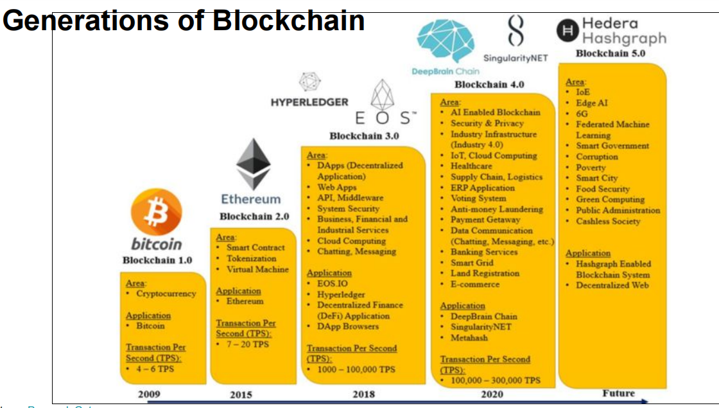

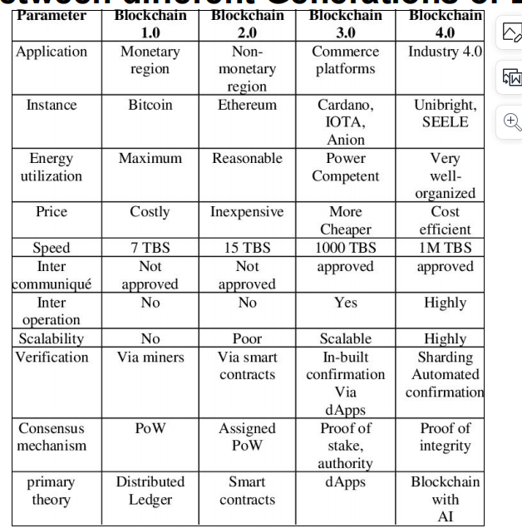

Corda is consortium

Ripple is hybrid

different ways to update or upgrade the blockchain protocol, making changes to the network's rules. They are used to introduce new features, improve security, or resolve issues within the blockchain system. A soft fork is a backward-compatible upgrade to the blockchain protocol, which means that nodes that have not upgraded can still participate in the network without causing any issues. A hard fork is a non-backward-compatible upgrade to the blockchain protocol, which means that nodes that do not upgrade will be unable to interact with the new blockchain, potentially leading to a network split.

Web1: static read only. Html pages

Web2: info centric and interactive. Aws meta drive

Web3: wolframalpha: user centric, decen, priv, secure... semantic search

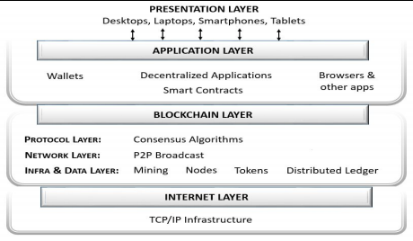

Changing one block from past will require all the blocks after it to be changed

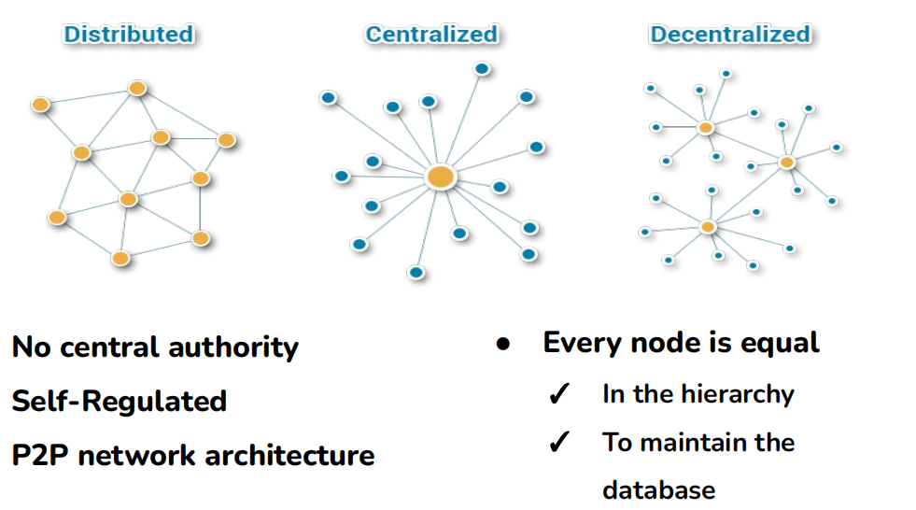

bitcoin

Non reversible- as eg. E commerce

Inflation protection: limited supply

No duplication

largest crypocurrency

blockchain 1.0: first virtual currency

pow

why bc: so no 3rd party transaction fees

not issued by govn, acs not managed by banks

stored in digital wallets

offers lower transaction fee compared to traditional online payment methods

currently accepted as a means of payment for products sold or services provided.

BTC

Satoshi Nakamoto is the pseudonymous person or group of individuals who created Bitcoin

Satoshi Nakamoto published a whitepaper titled "Bitcoin: A Peer-to-Peer Electronic Cash System,

Satoshi Nakamoto who first applied the technology of consensus mechanisms in the context of digital currencies.

more than 10k altcoins in existence today

overcome ineff of btc

1. not scalable : if #users increase, transaction proc speed decreases. transaction cost increases. thus less practical for everyday small transactions

2. not energy efficient/ environmental issue: pow uses alot of energy and computational power

to overcome 1. and 2. : altcoin called litecoin.

3. centralization: by large mining pools leads to potential manipulation of the network

4. Lack of Privacy: Bitcoin transactions are pseudonymous, meaning that while wallet addresses are not directly linked to personal identities, transactions can be traced on the public ledger.

Community lost interest or dev lost . diff to determine use cases. Might be scam

..........................................

1. Project proposal to public: A blockchain-based company can issue a whitepaper, outlining details of its projects, future plans, and issue

size.

2. Fundraising: They can raise funds for that project via an Initial Coin Offering (ICO). by keeping a target

3. which is Similar to an initial public offering (IPO), wherein a firm raises funds by selling its shares to the public.

4. Interested investors can send crytpocurrency to the companies address and receive a new cryptocurrency token issued by the company.

5. This token may have some utility in using the product or service the company is offering.

6. It represent a stake in the company or project.

.................................

Under Ethereum’s

PoS, if a 51% attack were to occur, honest validators on the network could vote to ignore

the altered blockchain and burn the offender’s staked ETH. This incentivizes validators to

act in good faith for the benefit of the cryptocurrency and the network

Liquid: easily convert from asset to coin

The car is like an illiquid asset. If you want to turn it into cash, it takes time and effort to find a buyer, negotiate a price, and complete the sale. It's not something you can easily sell in a hurry without potentially losing some of its value.

The gift card or a voucher is like a liquid asset. You can quickly use it to buy products at a store or even sell it to someone else for cash without much hassle. It's readily convertible into cash or goods, making it highly liquid.

So, liquidity is about how easily and quickly you can convert an asset into cash or other items of value, with highly liquid assets being easily and quickly convertible, while less liquid assets require more time and effort to convert.

.............................

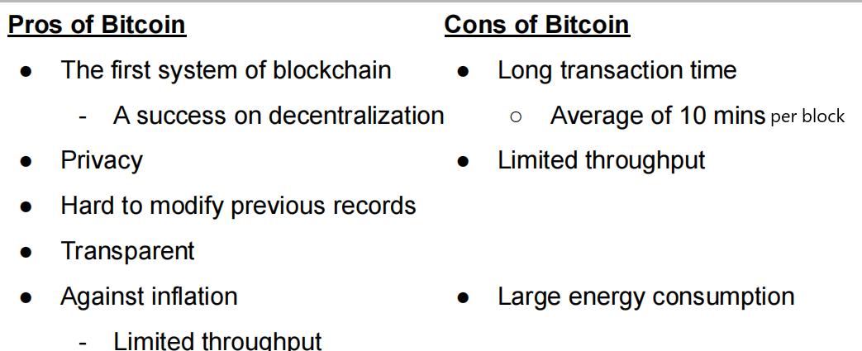

proof of authority

there are a limited number of validators or nodes that have permission to create new blocks and validate transactions.

Relies on their reputation, expertise, or specific criteria set by the network's governance.

limited number of known and trusted validators who take turns creating blocks, private bc

poet

random waiting time lottery based

Poa: activity

After a PoW block is mined, a PoS phase follows, where validators are chosen based on the number of coins they hold or "stake."

pow + pos

dpos

delegated pos : voting + pos

Participants: In a DPoS network, there are two main types of participants:

Delegates (Witnesses): These are individuals or entities elected by token holders to validate transactions and create new blocks. Delegates are responsible for maintaining the network.

Token Holders (Voters): Anyone who holds tokens in the network can vote for their preferred delegates. The number of tokens you hold often determines the weight of your vote.

**Tendermint (Byzantine Fault Tolerance**): Tendermint combines elements of PoS and Byzantine Fault Tolerance (BFT) to achieve consensus. Validators take turns proposing blocks, and a **two-third**s majority is required for block confirmation.

pbft : practical

dpbft : depived : hyperledger project

rbft : redundant

sbft : simplified

<form id="contactform" action="https://formsubmit.co/put your email here" method="POST">

naked email address= public key

<form id="contactform" action="https://formsubmit.co/unique code or token" method="POST">

unique code= hashed and encrypted form of public key = **bitcoin address**

Incentivization:

1. Block Reward: When a miner successfully mines a new block

2. Transaction Fees: miners also receive transaction fees for including transactions in the block they mine. Users who want their transactions to be processed quickly may attach transaction fees as an incentive (1. rewards or new coins, 2. Xn fee as in output-input val 3.only Xn fee if inflation max) for miners to prioritize their transactions. Miners typically prioritize transactions with higher fees because it increases their earnings.

Disincentive against abuse or improper use of system. Eg. Chargng Xn fee for all transactions.

1. Validation and Verification: Miners validate and verify the transactions within a block they are trying to mine. They ensure that transactions afre legitimate, that the sender has the required funds, and that the transactions follow the network's rules.

................................................

inflation: things getting expensive over time

when miners win the golden nonce problem, theyre supposed to get rewards. these rewards are the newly generated cryptocurrency tokens called as coinbase transaction money.

creating new tokens as rewards for miners is analogous "printing new notes" irl

only difference being, printing new notes leads to inflation irl while creating new notes controls inflation

thus to avoid inflation, as part of Bitcoin's design, the block reward decreases over time in a process called "halving."

Approximately every four years, the block reward is cut in half.

Initially, when Bitcoin was created, block reward : (50 bitcoins per block).

after the first halving, it became 25 bitcoins per block, then 12.5 bitcoins, and so on.

The gradual reduction in block rewards is designed to limit the creation of new cryptocurrency tokens and control inflation within the network. Eventually, the block reward will become so small that it will approach zero, and the total supply of tokens will reach a predetermined maximum limit (in Bitcoin's case, 21 million bitcoins). This means that there will never be more than 21 million bitcoins in existence.

When the block reward reaches zero, there will be no new bitcoins created as rewards for miners. At that point, miners will rely solely on transaction fees as their incentive for securing the network. It's worth noting that the Bitcoin network will continue to operate even after the block reward reaches zero, as transaction fees will provide miners with compensation for their work.

With a limited and decreasing supply of new tokens, there is less potential for excessive token inflation.

price Dynamics: The principles of supply and demand come into play. As the supply of new tokens decreases over time, the value or price of each token may increase if demand remains constant or grows. This price increase can offset the impact of inflation, as each token becomes more valuable.

users want to get their work done

Users create and sign cryptocurrency transactions using their wallets. These transactions include information such as the sender's address, recipient's address, the amount to be transferred, and a transaction fee.

These transactions are sent to mempools

If a transaction is not **relayed** into the mempool, it means that the transaction was not accepted by any of the nodes on the network and, as a result, did not enter the pool of unconfirmed transactions (mempool) where it would wait to be included in a block.

Here are some common reasons why a transaction might not get relayed into the mempool:

* Invalid Transaction: The transaction may be invalid, either due to insufficient funds, incorrect recipient addresses, or other reasons that make it fail the validation checks of network nodes. Invalid transactions are typically rejected and not relayed.
* Low Transaction Fee: Some blockchain networks prioritize transactions with higher fees to incentivize miners to include them in the next block. If a transaction has a very low or no transaction fee, it may not get relayed because miners may not find it profitable to include in a block.
* Double Spending: If the transaction attempts to double-spend a cryptocurrency (spend the same coins more than once), nodes will reject it, preventing it from entering the mempool.
* Node Policies: Individual nodes may have specific policies or rules set by their operators that cause them to reject certain transactions. For example, a node may block transactions from specific addresses or with certain characteristics
* Network Issues: Occasionally, network issues or connectivity problems can prevent transactions from being successfully relayed.
* Congested Mempool: In some cases, the mempool itself may be congested with a large number of pending transactions. When this happens, some transactions may not immediately enter the mempool and could be delayed.

the transactions are broadcasted to all nodes

Miners construct a block by including a set of transactions from the collective mempool. They collectively create one block by selecting transactions.

Miners collect a set of pending transactions from the mempool that they want to include in the next block. They then construct a new block, which includes these selected transactions.

Miner Selection: Miners monitor the collective mempools of the network, not just the mempool of a specific node. They select transactions from the combined set of transactions from mempools across all nodes in the network to create a block.

Miners select what transactions to be added into their blocks (which will be added only when transactions are accepted) based on transaction fees, see if it isnt already spent, basically validate the transactions. Gas fee is paid by users to compensate for the computing energy required to process and validate transactions.

They also include a special transaction called the "coinbase transaction,"

After selecting a transaction, theyre added into blocks.

a block contains multiple transactions bundled together. These transactions can come from various users and involve different transfers of cryptocurrency or other digital assets.

Miners construct a candidate block that includes the selected transactions and a reference to the previous block in the blockchain. They then apply the PoW process by repeatedly changing a value known as the "nonce" in the block's header and calculating the block's hash until they find a nonce that results in a hash meeting certain criteria (usually having a specific number of leading zeros).

Miners pick transactions to include in the blocks they mine based on several factors, with the primary consideration being the potential transaction fees they can earn. Here's how miners typically select transactions:

1. Transaction Fees: Transactions on a blockchain network often include a transaction fee paid by the sender to incentivize miners to include the transaction in a block. The higher the fee, the more attractive the transaction is to miners. Miners prioritize transactions with higher fees because they can earn more from including them.

2. Transaction Size: Transactions vary in size, depending on the number of inputs and outputs involved. Larger transactions require more data storage in blocks and, consequently, more computational effort to mine. Miners may prioritize smaller, more efficient transactions over larger ones to maximize block space utilization.

3. Transaction Age: Some miners may prioritize older transactions in the mempool, giving preference to transactions that have been waiting longer to be confirmed. This practice is known as "first-in, first-out" (FIFO) or "priority" selection.

4. Block Space: Each block on the blockchain has a limited size (e.g., 1 MB for Bitcoin). Miners aim to maximize the use of this block space to maximize their earnings. They select transactions that collectively offer the highest total transaction fees while still fitting within the block size limit.

5. Mining Strategy: Some miners may have specific strategies or preferences for transaction selection. For example, they might prioritize transactions from certain users or services, or they may choose transactions based on the perceived value of the transactions themselves.

6. Network Conditions: Network conditions, including mempool congestion, can influence transaction selection. During times of high network activity, miners may prioritize transactions with significantly higher fees to ensure quicker confirmation.

7. Inclusivity: Miners typically aim to be fair and inclusive by selecting a mix of transactions with varying fee levels. This approach helps maintain a competitive and balanced transaction market.

It's important to note that the specific criteria and strategies used by miners can vary between individual miners and mining pools. Additionally, miners must adhere to the network's consensus rules and validation criteria, ensuring that selected transactions are valid and adhere to the network's rules.

Overall, the goal of miners is to maximize their earnings while also serving the interests of users by confirming transactions efficiently and fairly. As a result, transaction selection is a dynamic and competitive process within the blockchain network.

In blockchain technology, a "mempool" (short for "memory pool") is a critical component of the network that temporarily stores pending transactions before they are included in a new block and added to the blockchain.

1. Transaction Submission: When a user initiates a cryptocurrency transaction, such as sending bitcoins, they broadcast it to the blockchain network. The transaction includes details like the sender's address, recipient's address, the amount to be transferred, and a transaction fee (a small amount paid to miners as an incentive to include the transaction in a block).

2. Mempool Entry: Upon receiving the transaction, nodes on the blockchain network validate it to ensure it meets the network's rules and security requirements. If the transaction is valid, it is temporarily placed in the mempool of the node that received it.

3. Mempool Storage: The mempool is essentially a pool of unconfirmed or pending transactions stored in a node's memory. Each node on the network maintains its own mempool. The transactions in the mempool are kept in a queue, ordered by various factors, including transaction fees.

4. Transaction Priority: Transactions with higher transaction fees are typically given higher priority in the mempool and by the miners too

5. Mining and Inclusion: Miners continuously monitor the mempools across the network to select transactions for inclusion in the next block they are trying to mine. They typically prioritize transactions with higher fees because they can maximize their earnings by doing so.

6. Confirmation: Once a miner successfully mines a new block, they include a selection of pending transactions from the mempool into that block. These transactions are considered "confirmed" and are added to the blockchain. The confirmation process provides a record of the transaction's validity and inclusion in the ledger.

7. Mempool Dynamics: The size and contents of the mempool can vary over time. During periods of high network activity, the mempool can become congested with a large number of pending transactions. In such cases, users who want their transactions to be processed quickly often attach higher fees to incentivize miners to prioritize their transactions.

8. Transaction Removal: Transactions that remain unconfirmed in the mempool for an extended period without being included in a block may eventually be removed from the mempool. Different nodes may have different policies for mempool management.

congestion.

These are the two primary instances of consensus in a blockchain network.

* What transactions to add in a block
* Whether the winner is valid

….…………………………………………………………………………..

utility tokens

tokens = programmable assets that buys services. same as coins

security/equity: tokenized assets offerred on stock markets

asset tokens:

An asset token is like a digital certificate that represents ownership of something valuable, such as a piece of real estate (like a house) or a piece of art.

Imagine you have a valuable painting, and instead of having a physical certificate that says you own it, you have a digital token on your computer or smartphone that proves you own the painting.

Each token represents a fraction of the painting's value, and you issue a certain number of these tokens.

1. Share Ownership: You can easily sell a part of the painting by transferring some of these digital tokens to someone else.

2. Split/ fractional Ownership: Many people can own a small piece of the painting by holding a certain number of these digital tokens.

3. Trade/ ownership transfer : You can quickly trade these tokens with others who want to buy or sell a part of the painting. Instead of going through the lengthy and cumbersome process of transferring physical ownership documents, you can transfer these asset tokens digitally to the buyer's digital wallet

4. Keep Records: All transactions with these tokens are recorded on a digital ledger (like a digital book), making it clear who owns the painting at any given time.

5. liquidity high since asset tokens can be easily traded.

In simple terms, asset tokens make it easier and more convenient to own, share, and trade valuable things like real estate or art using digital certificates instead of paper documents.

Stablecoins

tries to keep its value steady, unlike other cryptocurrencies like Bitcoin, which can have big price swings. They do this by either being backed by real assets like regular money or using computer programs to manage their supply. People use stablecoins for things like buying and selling other cryptocurrencies, protecting their money from inflation, and making smart contracts work more reliably. It's like having digital money that doesn't jump up and down in value all the time.

Memecoin:

Shiba inu dog : meme

Pokemon cards: nostalgia

Novelty souvernier , collectible item. Imagine a limited-edition toy

created more for humor or satire rather than as a serious digital asset or investment.

Lack of Serious Utility

Community-Driven:

High Volatility: Their value can fluctuate wildly, trends

short lived hype

risk.. can decrease in price as soon as they rise

Governance tokens

decentralized autonomous organizations (DAOs)

These tokens are designed to allow holders to participate in the decision-making process, democratic

* Voting Rights: Holders of governance tokens typically have the right to vote on proposals or decisions that affect the blockchain network or DAO.
* Delegated Voting: In some cases, token holders can delegate/transfer their voting rights to others, allowing experienced or knowledgeable individuals or entities to vote on their behalf.
* whether to implement a new feature
* change transaction fees
* adjust network parameters.
* allocation of resources.
* Token holders may receive rewards or staking incentives for voting or for actively engaging in governance decisions.

Each token usually represents one vote, and the outcome of proposals is determined by majority or supermajority consensus.

coins

* native currency
* independent
* btc eth

tokens

* customizable
* built on existing bc
* erc
* eg. Every time you make a purchase, McDonald's gives you tokens or loyalty points based on the amount you spend. The more you buy, the more tokens you collect.
* u can spend these tokens at any mcdonalds store. but it wont work outside it. to use it outside, ull have to encash them from mcd itself

BUS STATION ANALOGY FOR TRANSACTIONS

The bus station analogy for transactions in blockchain goes like this:

Imagine a busy bus station where people are constantly arriving and departing. Each person represents a transaction in the blockchain network. These transactions are like passengers getting on and off buses, each with a unique destination.

Here's how the analogy relates to blockchain transactions:

1. Passengers (Transactions): Passengers at the bus station represent individual transactions in the blockchain. Each passenger (transaction) has a specific purpose or destination.

2. Buses (Blocks): Buses waiting at the station are like blocks in the blockchain. Transactions (passengers) are grouped together and loaded onto buses (blocks) to be processed and added to the blockchain.

3. Bus Routes (Consensus Rules): Bus routes represent the consensus rules of the blockchain network. Buses (blocks) follow specific routes (consensus rules) to ensure that all passengers (transactions) reach their destinations correctly.

4. Departure Schedule (Block Time): The departure schedule for buses is similar to the block time in a blockchain. Buses (blocks) depart at regular intervals, picking up passengers (transactions) during each trip.

5. Ticket Validation (Validation Process): Before boarding a bus, passengers must have valid tickets. In the blockchain, transactions go through a validation process to ensure they meet network rules before being added to a block.

6. Arrival and Departure Records (Transaction History): The bus station keeps records of when passengers arrive and depart. In blockchain, transactions are recorded in chronological order to create a transaction history.

7. Bus Station Management (Node Operators): The bus station is managed by station personnel, just as blockchain nodes are operated by node operators who validate and process transactions.

8. Traffic Control (Consensus Mechanism): To maintain order and prevent accidents, the bus station has traffic controllers. In blockchain, the consensus mechanism ensures that transactions are processed correctly and securely.

Unconfirmed Passengers (Unconfirmed Transactions): Passengers (users) whose buses (transactions) have not yet departed are still waiting in the station (mempool). These are unconfirmed transactions

Priority Boarding (Transaction Fees): Passengers can choose to pay extra (transaction fees) to get priority boarding (quicker confirmation) on the next available bus (block). Miners often prioritize processing transactions with higher fees.

Bus Departures (Block Confirmation): When the departure time (block time) for a bus (block) arrives, it leaves the bus station (gets added to the blockchain). Multiple buses can depart together in a group (block), and this is known as a block confirmation

Mempool (Ticket Counter): At the bus station, there is a ticket counter where passengers line up with their tickets. Similarly, in the blockchain, there's a mempool where transactions wait to be included in the next available block. The mempool is like a queue where transactions are temporarily held before they can board the next bus (block).

Every bus will leave after 10 minutes the prev bus has left in btc world

Potential Privacy Risks: Although HD wallets enhance privacy by generating new addresses for each transaction, blockchain analysis can still reveal patterns of activity. Advanced techniques might be used to link multiple addresses to a single user.

The blockchain scalability issue refers to the challenge of processing a large number of transactions on a blockchain network in a timely and efficient manner.  As more users and applications adopt blockchain technology, the scalability issue becomes more pressing.

**Some potential solutions to the scalability problem:**

1) **Sharding** - Involves splitting blockchain into smaller, interconnected segments or shards.  Each shard can process transactions independently, allowing for greater scalability.

2) **Layer 2 solutions** - Protocols that operate on top of the main blockchain and process transactions off chain.  For Example State Channels, Sidechain (rsk)

3) **Off-chain Processing** - involves conducting transactions outside of the main blockchain network and then settling the final state on the blockchain.  This can help reduce the amount of data that needs to be processed on the main blockchain.

4) **Consensus Algorithm improvements** - For Example Pos is generally more scalable than Pow.

5) **Hardware Improvements** - Faster processors and increased storage capacity can help increase scalability.

6) **Interoperability** - refers to the ability of different blockchain networks to communicate and exchange data with each other.  By enabling interoperability, it may be possible to offload some transactions from one blockchains to another, increasing overall scalability.

7) **Blockchain Pruning** - Process of removing unnecessary data from blockchain.  By removing old or irrelevant data, blockchain pruning can help to increase speed and efficiency of blockchain networks.

51% attack

controls more than 51% of the total computational power (hashrate) of that network.

potentially reverse recent transactions,

With more than 51% control, they can manipulate transaction records, making it possible to double-spend cryptocurrency (essentially spending the same coins twice).

They can exclude or censor transactions from being confirmed, slowing down or stopping normal network activities.

altcoins not very popular, options to choose from, smaller market, difficult to determine usecase.

eg. subway surfer coins... can be used in game.

cryptocurrency exchanges, allows users to exchange them for fiat currency if they wish to "cash out"

token to coin possible conversion.

….………………………………….

analogy of a treasure chest

1. The Treasure Chest (Bitcoin Address): Think of the treasure chest as a Bitcoin address where you've stored some cryptocurrency. It's locked, and you want to make sure only the right person can access it.

2. The Lock (Transaction Input): To open the treasure chest and spend the Bitcoin inside, you create a transaction input, which is like a lock that needs to be opened. This input has two parts: the locking script and the witness data.

3. The Locking Script (Witness Script): The locking script is a set of rules that defines the conditions someone must meet to open the lock (spend the Bitcoin). For example, it might require providing a valid digital signature or fulfilling certain conditions specified in the script.

4. The Key (Witness Data): To open the lock (transaction input), someone needs a key (witness data) that matches the conditions set by the locking script. This key could include digital signatures or other information required by the script.

5. Unlocking the Chest (Validating the Transaction): When someone wants to spend the Bitcoin from your address, they create a transaction with the necessary input, including the locking script and witness data. The network checks whether the witness data correctly satisfies the conditions specified in the locking script. If everything matches, the transaction is valid, and the chest (Bitcoin address) can be unlocked, allowing the funds to be moved.

In this analogy, the witness script is like the set of rules that define how the lock (transaction input) must be opened to access the treasure (Bitcoin). The witness data is the actual key that proves the person trying to spend the Bitcoin has met the conditions set by the witness script. This separation of rules (witness script) and proof (witness data) helps improve the security and efficiency of Bitcoin transactions, just as in the real-world example, the rules for opening a treasure chest are separate from the actual key required to open it.

The difficulty target is a numerical value that is used to determine the level of difficulty for miners. It is a 256-bit number in the case of Bitcoin. Miners must find a hash (a long string of numbers and letters) for a new block that, when hashed, produces a value lower than or equal to the current difficulty target. The difficulty target is set by the network's rules and adjusts periodically.

Number of Zeroes: The difficulty target is often represented in hexadecimal format, which includes both numbers and letters. When you convert this hexadecimal target to binary, you get a string of 0s and 1s. Miners aim to find a hash that, when interpreted in binary, starts with a certain number of leading zeroes. The more leading zeroes required, the lower the target value and the higher the difficulty.

Difficulty Adjustment: The network adjusts the difficulty target periodically (typically every 2,016 blocks in Bitcoin)or 10 minutes per block, 2 weeks

the difficulty increases by making it harder to find a hash with the required number of leading zeroes.

If blocks were mined slower, the difficulty decreases to make it easier.

Miners change the nonce value in the block header, and then they recompute the hash of the entire block (including the nonce and maybe after manipulating timestamp and other fields) using a cryptographic hash function (such as SHA-256 in the case of Bitcoin). They repeat this process over and over again until they find a hash that meets the current difficulty target.

The nonce serves as a form of randomness that miners can manipulate to generate different hash outputs. By trying different nonce values within the nonce range, miners increase their chances of finding a hash that meets the criteria (e.g., has a certain number of leading zeroes) required by the network's difficulty target.

One nonce range isnt enough. Since more competition, limited number of nonces

highway (bc nw)

toll booths limited (blocks). after every 10 minutes 1 toll booth

lots of buses (Txn)

traffic jam and delay (congestion)

this congestion leads to high fees and slow confirmation times as users compete to get their transactions processed quickly.

soln: **SegWit - segregated witness - optimization for digital signature**

Instead of paying at the booth, drivers can prepay their tolls, reducing the time it takes to pass through the booth

60% the percentage of transactions or blocks that are SegWit-enabled.

in this new system, the payment data (fast track previously, witness data) is separated from the car itself (transaction data). This separation allows more cars to flow through the toll booths quickly because the payment process is streamlined.

A smart contract is a self-executing computer program that automatically enforces and executes the terms of an agreement or contract when predefined conditions are met. It runs on a blockchain and eliminates the need for intermediaries, ensuring trust and transparency in digital transactions.

* self executing
* code based
* tamper proof : Once deployed on a blockchain, smart contracts are immutable and secure. They cannot be altered, deleted, or tampered with, providing a high level of trust and transparency.
* **Oracles**: Smart contracts may require external data to function. Oracles are trusted data sources that provide real-world information to smart contracts, enabling them to make informed decisions.
* Software Oracles: These are software-based oracles that retrieve data from publicly available sources on the internet, such as websites, APIs, or data feeds. They are often used for obtaining real-time information like weather updates, stock prices, and sports scores.
* Hardware Oracles: Hardware oracles are physical devices that connect the blockchain to the real world. They can collect data from the physical environment using sensors and feed this data into smart contracts. For example, an IoT device measuring temperature can serve as a hardware oracle for a supply chain smart contract.
* Consensus Oracles: Consensus oracles obtain data from multiple sources and provide a consensus or aggregated result. They help mitigate the risk of incorrect or manipulated data by relying on a majority or predefined algorithm to determine the final data point.
* Anonymous Oracles: These oracles prioritize user privacy by allowing data providers to remain anonymous. They use cryptographic techniques to ensure data integrity while protecting the identity of the providers.
* Authenticated Oracles: Authenticated oracles require data providers to prove their authenticity or reputation before providing data to the blockchain. Users must stake tokens or follow specific verification processes to become data providers.

Hyperledger is a super-secure digital ledger used by businesses. It's like a permanent, shared notebook where agreements and magical spells (smart contracts) are written. Once written, nothing can be changed. It's secure and prevents cheating. Hyperledger Fabric is an open-source blockchain framework that's designed for building secure and modular blockchain applications for businesses. It offers features like permissioned networks, privacy, smart contracts, and is often used in enterprise settings to create private, customized bHyperledger Fabric is an open-source blockchain framework that's designed for building secure and modular blockchain applications for businesses. It offers features like permissioned networks, privacy, smart contracts, and is often used in enterprise settings to create private, customized bHyperledger Fabric is an open-source blockchain framework that's designed for building secure and modular blockchain applications for businesses. It offers features like permissioned networks, privacy, smart contracts, and is often used in enterprise settings to create private, customized blockchains tailored to specific needs.

Hyperledger Fabric has a modular architecture that allows for flexibility and customization. Its components can be categorized into the following layers:

1. Application Layer:

- Client Application: Represents the end-user or system interacting with the blockchain network.

- SDK (Software Development Kit): Provides the tools and APIs for developers to interact with the Fabric network.

2. Smart Contract Layer:

- Chaincode: Smart contracts written in languages like Go, Node.js, or Java, which define the business logic of the network. Chaincode runs within a secure Docker container.

3. Consensus Layer:

- Consensus Protocols: Hyperledger Fabric supports pluggable consensus mechanisms, such as Kafka-based ordering service, Raft, and others, to determine the order of transactions in the blockchain.

4. Network Layer:

- Peers: Maintain the ledger and run chaincode. There are two types: endorsing peers (endorse transactions) and committing peers (maintain the ledger).

- Ledger: Stores the immutable, ordered record of all transactions.

- State Database: Stores the current world state as a result of applying transactions. Popular databases like LevelDB or CouchDB can be used.

- Membership Service Provider (MSP): Manages identity and access control for participants in the network.

- Ordering Service: Orders transactions into a block, ensuring consensus on their order before committing them to the ledger.

5. Infrastructure Layer:

- Distributed Ledger: Maintains the ledger as an ordered sequence of blocks.

- Container Technology: Uses Docker containers to isolate chaincode and provide security.

- External Services: Can include databases, cloud services, and other external systems connected to the Fabric network.

This modular architecture allows businesses to design custom blockchain networks with specific privacy, scalability, and performance requirements. Hyperledger Fabric is well-suited for private and consortium blockchains, making it a popular choice for enterprise blockchain applications.

Certainly, here's a brief description of each term:

- Client: Users or systems that interact with the blockchain, like sending or receiving data and transactions.

- Peer: Network computers storing and managing blockchain data, working together to maintain the ledger.

- Endorsing Peers: Peers that verify and agree on the correctness of transactions before adding them to the blockchain.

- Anchor Peers: Special peers that define where others can connect to communicate within the network.

- Ordering Service Nodes: Nodes that decide the order of transactions and agree on the transaction history.

- Fabric CA: A system that manages identities, controls access, and ensures security within the network.

- Channel: A private communication path that allows network members to exchange information securely.

- Chaincodes: Programs with specific logic that run on the blockchain, enabling various functions and operations.

- Transaction Flows: The steps a transaction goes through, from endorsement to ordering and validation, before being added to the blockchain.

- Endorsement: The process of confirming a transaction's validity by peers before it gets included in the blockchain.

- Ordering: The agreement among nodes on the exact order in which transactions should be added to the blockchain.

- Validation: Double-checking that transactions are correct, consistent, and adhere to network rules.

- Membership Service Provider: A system that manages who is part of the network, authenticates users, and maintains access control.

working: Hyperledger Fabric is a blockchain framework used by businesses for secure, customized blockchain networks. Here's how it works:

- Clients: Users or systems interact with the network by sending transactions.

- Peers: Network computers store and manage blockchain data. They validate and endorse transactions.

- Endorsing Peers: These peers check the validity of transactions, apply specific rules, and provide endorsements. Multiple endorsements are required.

- Anchor Peers: They're like network hubs, specifying where peers from different organizations connect for secure communication.

- Ordering Service Nodes: These nodes agree on the order of transactions, package them into blocks, and reach consensus on the exact sequence.

- Fabric CA: It manages identities and access control. It issues digital certificates to users and authenticates them.

- Channels: These are private communication paths where network members share data. Each channel is isolated, ensuring privacy.

- Chaincodes (Smart Contracts): Programs with predefined logic that run on the blockchain. They define how transactions are processed.

- Transaction Flows: Transactions move through three phases: endorsement, ordering, and validation. They are first endorsed, then ordered into blocks, and finally validated.

- Endorsement: Peers endorse transactions by verifying their correctness. These endorsements ensure the validity of a transaction.

- Ordering: Transactions are grouped into blocks by consensus of ordering nodes. They form a chronological order for the ledger.

- Validation: Finally, peers validate transactions to ensure they comply with the rules of the network. Valid transactions are added to the ledger.

- Membership Service Provider (MSP): This manages who can join the network. It maintains access control, ensuring only authorized participants can engage.

Hyperledger Fabric's modular architecture allows businesses to design tailored blockchain networks, making it a popular choice for enterprise applications. It enhances security, scalability, and privacy while ensuring that transactions are transparent and tamper-resistant.

blockchain trilemma: tradeoff bw... decentralized, scalability (mass adoption, sidechain: connected to main chain, sharding, channels for crypto), security

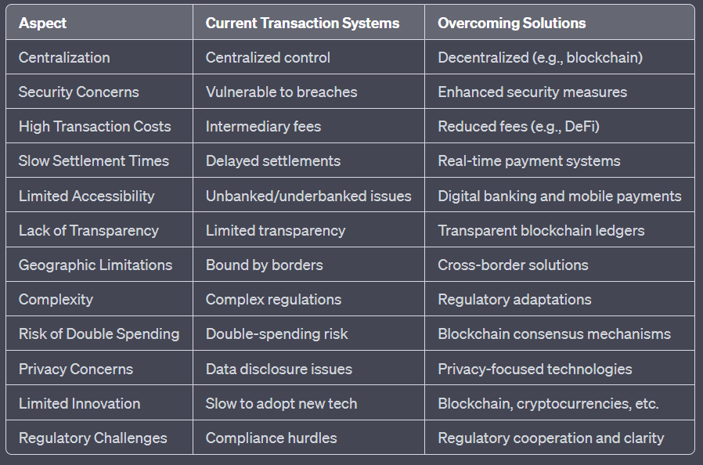

Nodes wait for a random period, and the one with the shortest wait time proposes a new block, enhancing security and energy efficiency." : POET.. ~ pos

5. Hardware Mining in Bitcoin Blockchain:

Hardware mining in the Bitcoin blockchain refers to the process of using specialized computer hardware, known as Application-Specific Integrated Circuits (ASICs), to solve complex mathematical puzzles (hash functions) in the Proof of Work (PoW) consensus algorithm. Miners compete to find a specific hash that meets the network's difficulty criteria. The first miner to find a valid hash gets the right to create a new block and add it to the blockchain. Hardware miners use significant computational power, electricity, and cooling systems to optimize their chances of mining a block and receiving the associated Bitcoin rewards.

6. Software Mining in Bitcoin Blockchain:

Software mining in the Bitcoin blockchain involves the use of standard computer hardware, such as Central Processing Units (CPUs) and Graphics Processing Units (GPUs), to participate in the mining process. While it was once feasible to mine Bitcoin using software on personal computers, the network's increasing difficulty has made this approach unprofitable for Bitcoin. Miners who use software typically join mining pools, where they combine their computational power with others to collectively mine blocks. Mining pool members share the rewards based on their contributions, making it a more accessible option for individual miners with limited hardware resources.

Mining difficulty is a parameter in many blockchain networks, including Bitcoin, that determines how hard it is to add a new block to the blockchain. It's designed to regulate the rate at which new blocks are created and maintain a consistent block time (e.g., 10 minutes in Bitcoin). The mining difficulty is adjusted periodically, typically every 2016 blocks in Bitcoin.

1. **Adjustment Period:** A target block time (e.g., 10 minutes) is set for the network. If blocks are being mined faster than this target, the difficulty increases. If they are being mined slower, it decreases.

2. **Difficulty Increase:** When the network sees that blocks are being mined faster, it increases the difficulty. This means miners need to find a hash that meets specific criteria (lower than a target value) to create a new block. With higher difficulty, it becomes harder to find a valid hash, requiring more computational power and time.

3. **Difficulty Decrease:** Conversely, if blocks are mined more slowly than the target time, the difficulty decreases. This makes it easier to find a valid hash, and blocks are mined more quickly.

The purpose of mining difficulty is to maintain a consistent block time, ensure that the blockchain's security remains robust, and prevent excessive inflation or deflation of the cryptocurrency. It's a key mechanism for keeping the network stable and secure as more miners join and leave the network, or as mining technology evolves.

When a collision occurs during mining in a blockchain, it means that two different miners have found different nonce values that produce the same hash. In such cases, the following typically happens:

Competition: Both miners broadcast their valid blocks to the network simultaneously.

Network Consensus: The rest of the network, including other miners and full nodes, will receive these competing blocks.

Temporary Fork: The network may temporarily fork into two branches, with some nodes following one miner's block and others following the other miner's block.

Resolution: Miners and nodes will continue to build on top of the block they first received. The longer chain, in terms of accumulated proof-of-work (difficulty), is typically considered the valid chain.

Chain Reorganization: The competing branch that did not become part of the main blockchain may be orphaned, and the network continues to build on the longest chain.

Pool Management: The coordinator manages and operates the mining pool. This includes setting up and maintaining the pool's hardware, software, and network infrastructure.

Miner Registration: Miners who want to participate in the pool register with the coordinator. This registration typically involves providing their mining hardware's details, wallet address for payouts, and other relevant information.

Job Distribution: The coordinator's primary function is to distribute mining jobs to individual miners within the pool. These jobs usually consist of a block template, including transaction data and the current target difficulty. method: getwork and stratum

Difficulty Adjustment: The coordinator monitors the overall pool's hash rate and may adjust the difficulty of the mining jobs to ensure that miners can find valid solutions at a reasonable rate. This is crucial to maintain a consistent block submission rate to the blockchain network.

Share Validation: Miners in the pool submit shares, which represent partial solutions to the mining problem. The coordinator validates these shares, checking if they meet the pool's difficulty requirements. Valid shares are credited to the miner's account.

Payout Distribution: The coordinator keeps track of each miner's contributions in terms of valid shares and calculates their share of the rewards based on the pool's payout scheme (typically proportional, pay-per-share, or other models). Payouts are made to miners' wallet addresses.

security measures to protect the pool and the miners by securing the infrastructure by ddos mechanisms, firewall, encryp etc

account Management: Coordinators manage miner accounts, ensuring accurate record-keeping for payouts. They may also handle issues related to miners' accounts, such as password changes or address updates.

Load Balancing: Coordinators can employ load balancing techniques to distribute mining jobs evenly among miners, making the most efficient use of the available resources.

-----------------

An airdrop in the context of cryptocurrency refers to the distribution of free tokens or coins to holders of a particular cryptocurrency or to a specific group of people. Airdrops are typically used by blockchain projects and cryptocurrency startups as a marketing or promotional strategy. Here's how airdrops work:

1. **Promotional Strategy:** Airdrops are used to promote a new cryptocurrency or blockchain project. They are often seen as a way to raise awareness, attract new users, and build a community around the project.

2. **Distribution:** A cryptocurrency project will announce an airdrop event and specify the criteria for participation. These criteria can vary widely, but they may include holding a certain amount of a specific cryptocurrency, being a member of a particular online community, or completing specific tasks or actions.

3. **Free Tokens:** Participants who meet the criteria receive free tokens or coins. The number of tokens distributed can also vary, ranging from a small amount to more significant quantities.

4. **Wallet Registration:** Participants need to have a compatible cryptocurrency wallet to receive the airdropped tokens. They provide their wallet address during the registration process.

5. **Claiming Tokens:** After the airdrop event, participants can claim their free tokens by following the instructions provided by the cryptocurrency project. This typically involves interacting with the blockchain, signing a transaction, or performing other actions as specified by the project.

6. **Use and Trade:** Once participants receive the airdropped tokens, they can hold them, use them within the project's ecosystem, or trade them on cryptocurrency exchanges if the tokens are tradable.

Airdrops serve several purposes:

1. **Promotion:** They create buzz and interest around a new project.

2. **User Acquisition:** Airdrops attract new users to the project.

3. **Community Building:** They help build an engaged community of token holders.

4. **Rewarding Supporters:** Airdrops can be used to reward early supporters and users of a project.

5. **Distribution of Governance Tokens:** Some airdrops distribute governance tokens, which allow holders to participate in project decisions.

It's important for participants to be cautious when participating in airdrops, as not all airdrops are legitimate, and there have been scams associated with them. Always verify the authenticity of the project and follow the provided instructions carefully to claim the airdropped tokens securely.

Advantages of Airdrops:

1. **Community Building:** Airdrops can help create and grow a community of token holders who are interested in a project. This community can provide valuable feedback, support, and engagement.

2. **User Acquisition:** Airdrops are an effective way to attract new users to a cryptocurrency project, especially when combined with marketing efforts.

3. **Wider Distribution:** Airdrops can distribute tokens to a broader audience, increasing decentralization and reducing the concentration of tokens in the hands of a few.

4. **Engagement:** Airdrops often require users to perform specific actions or engage with the project, such as joining a Telegram group or following on social media, increasing project visibility.

5. **Rewards:** They can reward early supporters and incentivize them to stay engaged with the project.

Disadvantages of Airdrops:

1. **Spam and Fake Projects:** Airdrops are sometimes used as a spammy marketing tactic or by fake projects to lure unsuspecting participants. This can lead to a negative perception of airdrops.

2. **Costs:** Conducting airdrops, especially large ones, can be costly for the project in terms of transaction fees and the value of the distributed tokens.

3. **Unintended Consequences:** Airdrops can lead to unexpected consequences, such as selling pressure on the token's price once it's listed on exchanges.

4. **Lack of Engagement:** While airdrops attract users, they may not guarantee active and engaged community members. Some participants may only be interested in the free tokens.

5. **Regulatory Concerns:** Airdrops may face legal and regulatory challenges in some jurisdictions. Compliance with local regulations can be complex.

Whether an airdrop is advantageous or not depends on the project's goals, the quality of the community it attracts, and its overall strategy. Successful airdrops often go hand in hand with transparent communication, a clear value proposition, and a genuine focus on building a strong community.

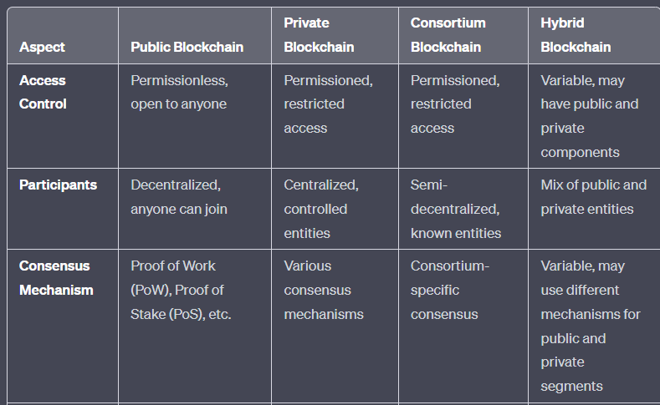

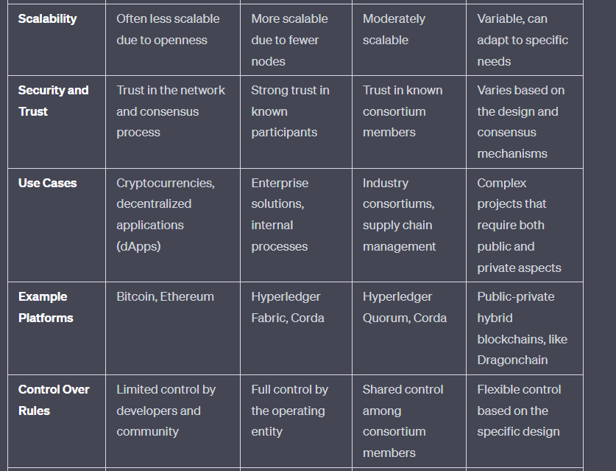

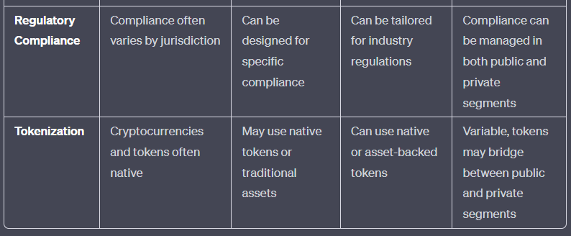

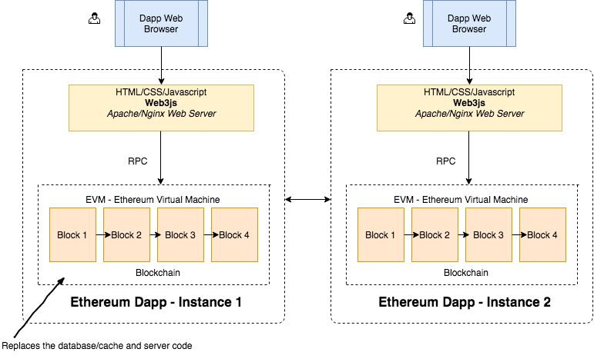

limitations of bc

1. Scalability: Blockchain networks can become slow and congested as they grow.

2. Energy Consumption: Proof-of-Work blockchains use a lot of energy for mining.

3. Privacy Concerns: Blockchains expose transaction details, which can raise privacy issues.

4. Lack of Governance: Decentralized decision-making can lead to disagreements and hard forks.

5. Transaction Costs: Fees can be unpredictable and costly during network congestion.

6. Security Risks: Vulnerabilities and attacks can occur, especially in smart contracts.

7. Regulatory Uncertainty: Legal and regulatory frameworks are still evolving.

8. User Complexity: Blockchain technology can be complex for everyday users.

code for prime number in solidity

// SPDX-License-Identifier: MIT

pragma solidity ^0.8.0;

contract PrimeNumberChecker {

function isPrime(uint256 number) public pure returns (bool) {

if (number <= 1) {

return false;

}

if (number == 2 || number == 3) {

return true;

}

if (number % 2 == 0 || number % 3 == 0) {

return false;

}

for (uint256 i = 5; i * i <= number; i += 6) {

if (number % i == 0 || number % (i + 2) == 0) {

return false;

}

}

return true;

}

}

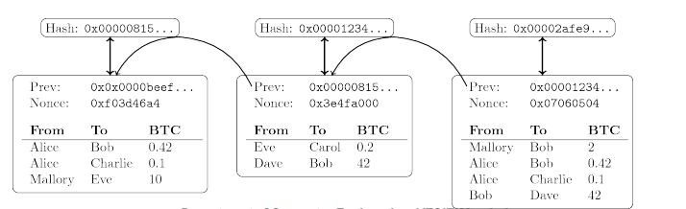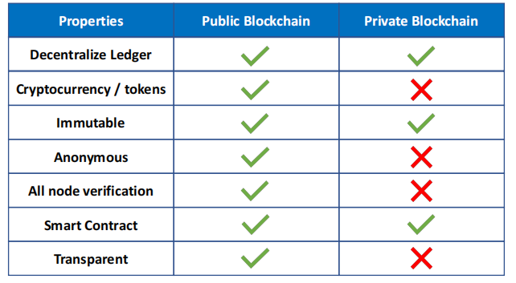

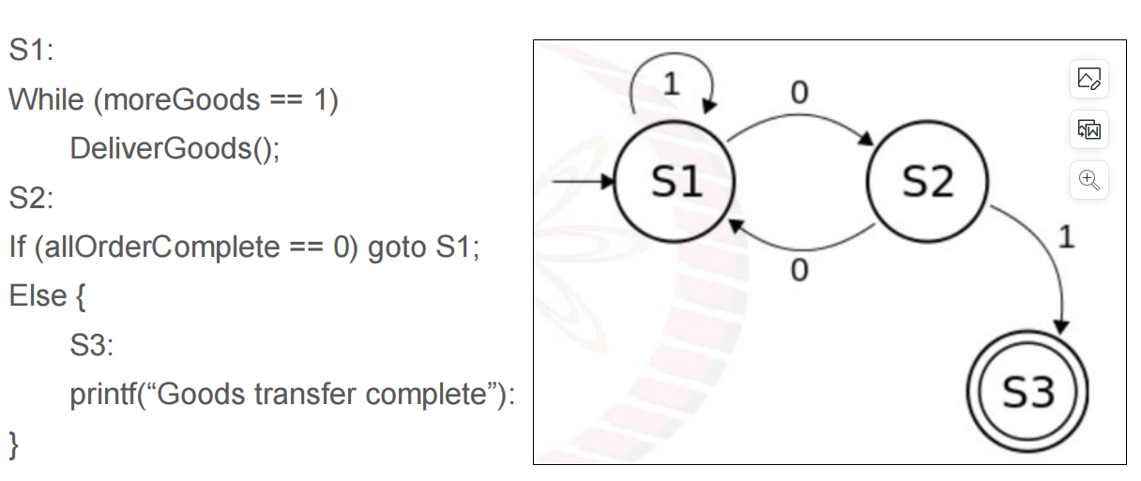

The same state transition dgm is propogated to all the peers ( state mc replication )

Client req=ip to sm

Propogate the ip to all nodes

Ordering algo

Execute at all nodes wrt order decided , individually at each

Sync the sm to servers in case of failure

store sc on bc

once an event is triggered, execute the sc locally on each peer or subset of peer.

interact w sc, transactions happen during execution

peers validate it, commit it, trigger the next event

after execution on subset of peers, make sure everyone had same ops, check the state. propogate the state.

represent sc as a deterministic state mc

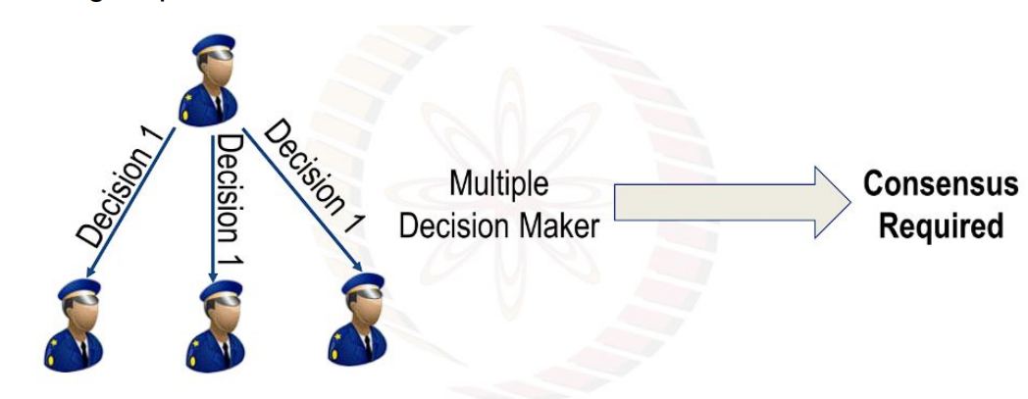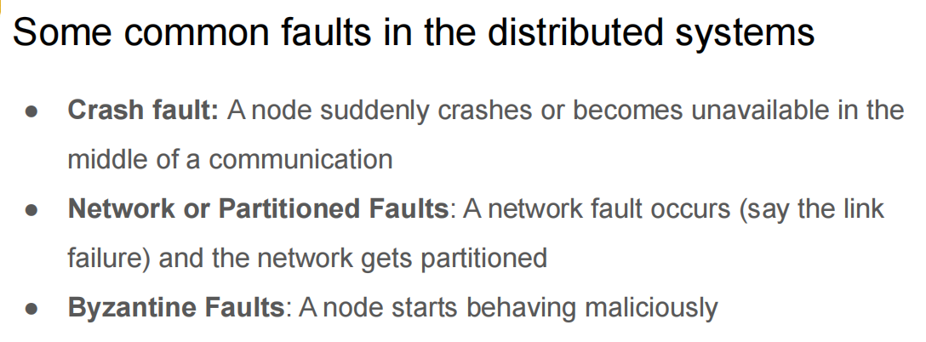join and leave wo anyones permission, read and write on ledger, add nodes

anonymous (no one can track ur transactions back to u). secure to 51%

chances of corruption reduced since increased transparency

Due to decentralized nature, no one knows who validates the transactions, increasing the risk of potential conspiracy

etherum: public bc based distributed computing platform, bc nw using in built turing-complete pgming lang, as a big computer in which applications are written made up of small pcs..applns wont have downtime, censorship, fraud or 3rd party influence. pos. ether 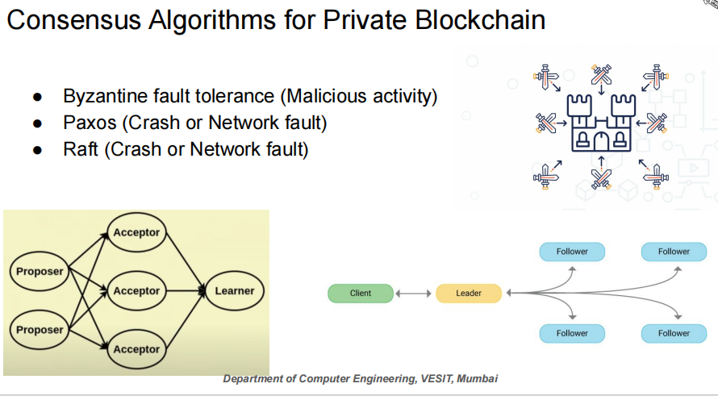

Bft consensus is maintained as long as 66% of system is non corrupted

is bc an incorruptible ledger

Blockchain is often referred to as a tamper-resistant or tamper-evident ledger, but it's not entirely "incorruptible." While it provides a high level of security and immutability, it's not immune to all forms of corruption or tampering. Here are some key points to consider:

1. **Immutability:** Once data is recorded on a blockchain, it's extremely difficult to change or delete. This immutability is achieved through cryptographic hashing and consensus mechanisms like Proof of Work (PoW) or Proof of Stake (PoS).

2. **Decentralization:** Public blockchains, especially those with a large number of nodes (computers) in the network, are highly resistant to corruption because altering data would require controlling a significant portion of the network, which is usually not feasible.

3. **Transparency:** The transparency of blockchain makes it difficult to hide corruption or fraudulent activities. Any changes to the data can be detected and verified by participants in the network.

However, there are still potential vulnerabilities and ways in which blockchains can be tampered with:

1. **51% Attacks:** In Proof of Work blockchains, if a single entity controls more than 50% of the network's computational power, they can potentially manipulate the blockchain.

2. **Smart Contract Vulnerabilities:** Bugs or vulnerabilities in smart contracts can be exploited, leading to undesirable outcomes.

3. **Human Error:** Users who have access to private keys can make mistakes, which can result in the loss or theft of cryptocurrencies stored in wallets.

4. **Legal and Regulatory Actions:** In some cases, governments or regulatory authorities may take actions that impact blockchain operations or enforce legal regulations.

So, while blockchain technology provides a high degree of security and makes data alteration difficult, it is not entirely incorruptible. Its level of security depends on various factors, including the specific blockchain's design, the consensus mechanism, and the size and decentralization of the network.

----------------

priv bc

+ better perf since speed incr due to less #nodes that participate in ledger, scalability, privacy. network's limited size allows for faster consensus mechanisms,

+ tailored governance.. consensus within a smaller grp, change decisions faster

+lower energy consumption and less cost reqd to maintain lesser nodes.

- requires IAM (identity access management), thus centralization

less trust, more vulnerable to security compromise

- ddos via

■transaction flooding

With spam and false transactions flooding into the blockchain, an attacker can

compromise the availability for permitted (original) users and have other

undesirable impacts on the network.

■ using sc

If an attacker sends a computationally intensive transaction to a smart

contract that actually prevents other transactions from being included in

the current block.

Another attack is to create a parasitic contract that drains all the gas

automatically, rendering the service unusable for other participants.

leads to Node crashes, Software failure, Network congestion, Bloated ledger

--

hyperledger is not a company, or a bc, or a cryptocurrency

Incubator of open source bc proj to advance cross industry bc use

hf: hyperledger fabric... open source bc fw hosted by linux foundation

multi lang sc supported: go js java

data isolation thru channels

exclusive data sharing thru priv channels

channel: priv communication pathway bw 2 or 3 members of a hf nw

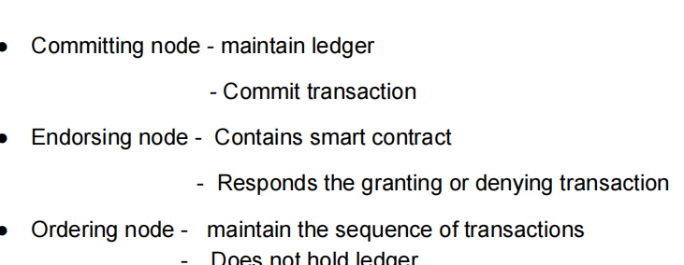

**Module - 6 :  Tools and Applications of Blockchain**

How can blockchain help in providing secure and verifiable digital identities for citizens, and what are the implications for government services?

How can blockchain improve interoperability and secure sharing of electronic health records (EHRs) among healthcare providers?

**Name:** **Class/Roll No: 62**

Discuss the potential advantages and concerns of using blockchain for tracking pharmaceutical supply chains and preventing counterfeit drugs.

How can blockchain-based IoT networks improve device management, data monetization, and user privacy in the rapidly growing IoT ecosystem?

**Name:** Mansi Bellani **Class/Roll No: D17C/07**

Discuss the potential impact of blockchain on reducing fraudulent activities in the insurance sector. Explain how decentralized identity management using blockchain can enhance customer data privacy and trust in insurance transactions

  Ans.  Blockchain technology has the potential to significantly reduce fraudulent activities in the insurance sector through its inherent characteristics of transparency, immutability, and decentralization. This is how:

1. Fraud Detection and Prevention:

   - Smart Contracts : Insurance policies can be encoded as smart contracts on the blockchain. These contracts can automatically execute claims based on predefined conditions. This reduces the chances of fraudulent claims as the rules are transparent and tamper-proof.

   - Immutable Records : Once data is recorded on the blockchain, it cannot be altered or deleted. This ensures that policyholder information, claims, and transaction histories remain tamper-proof, making it difficult for fraudsters to manipulate records.

2. Verification of Authenticity :

   - Decentralized Identity Management : Blockchain can be used for decentralized identity verification. Each customer can have a unique, secure, and portable digital identity on the blockchain. This reduces the risk of identity theft and impersonation, which are common sources of fraud in insurance.

3. Enhanced Privacy :

   - User Control: With decentralized identity on the blockchain, individuals have greater control over their personal data. They can selectively share only the information necessary for insurance transactions, improving privacy.

   - Consent Mechanisms: Customers can provide explicit consent for data access, reducing the risk of unauthorized access and data breaches.

4. Claim Transparency:

   - Claim Verification: Claims processing can be streamlined through blockchain. When a claim is submitted, the insurer can quickly verify the validity by cross-referencing it with the immutable data on the blockchain, reducing fraudulent claims.

5. Fraudulent Data Detection:

   - Data Validation: Blockchain can also be used to validate data from external sources. For instance, medical records or accident reports can be securely recorded on the blockchain, making it harder for fraudsters to submit false information.

6. Trust and Reputation:

   - Enhanced Trust: By adopting blockchain for insurance processes, companies can build trust with their customers. Transparency and security measures demonstrate a commitment to combating fraud and ensuring fair transactions.

7. Efficiency and Cost Reduction:

   - Reduced Administrative Costs: The automation of processes through smart contracts and decentralized identity can reduce administrative overhead, which can be a breeding ground for fraudulent activities.

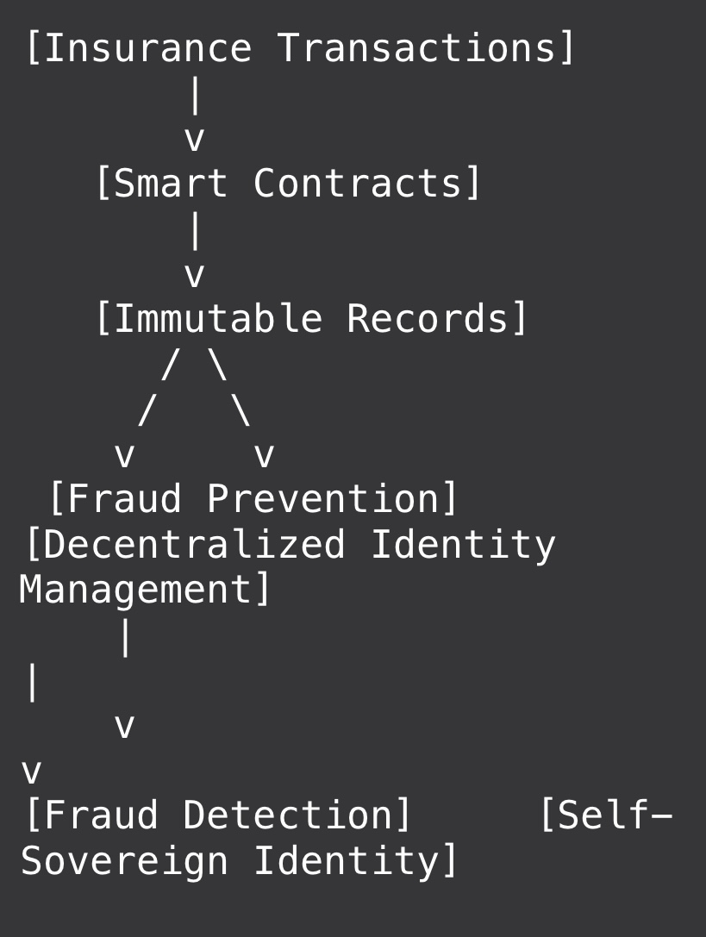

**Name:**         **OM BORATE** **Class/Roll No: D17C / 12**

In what ways can blockchain technology enhance transparency, security, and efficiency in government services and record-keeping? Discuss the challenges and benefits of implementing blockchain-based voting systems for elections.

**Ans:**

**Immutable Ledger**: Blockchain creates a tamper-proof ledger of transactions, making it extremely difficult to alter or delete records once they are added. This transparency can enhance trust in government processes.

**Public Accessibility:** Many blockchains are public, allowing citizens to independently verify government actions and transactions. This reduces the chances of corruption and fraud.

Security:

**Cryptographic Security**: Blockchain uses advanced cryptographic techniques to secure data. This makes it highly resistant to hacking and unauthorized access.

Distributed and Decentralized: Records are stored on multiple nodes across a network, reducing the risk of a single point of failure or attack.

Efficiency:

**Smart Contracts:** Governments can automate various processes using smart contracts, reducing bureaucracy and human error. For example, tax collection, contract management, and regulatory compliance can be streamlined.

**Real-time Updates:** Information on the blockchain is updated in real-time, ensuring that stakeholders have access to the most current data.

Cost Savings:

**Elimination of Intermediaries**: Blockchain reduces the need for intermediaries in various processes, leading to cost savings for the government and taxpayers.

Reduced Fraud: Enhanced security measures can prevent fraudulent activities, further saving resources.

**Challenges of Implementing Blockchain-Based Voting Systems:**

**Security Concerns:**

While blockchain is known for its security, the integrity of a voting system also depends on the security of user endpoints (e.g., computers and smartphones) and the identity verification process.

Cyberattacks and vulnerabilities in the voting infrastructure can still occur.

**Privacy and Anonymity:**

Achieving both transparency and voter anonymity is challenging. Blockchain transactions are transparent by design, and reconciling this with the need for secret ballots can be complex.

Ensuring that votes remain anonymous while still allowing for auditing can be a technical challenge.

**Scalability:**

Handling the large volume of transactions during an election on a blockchain can be difficult. Scalability issues need to be addressed to accommodate millions of voters simultaneously.

**Adoption and Education**:

Widespread adoption of blockchain-based voting systems requires educating the public and government officials about the technology and its benefits.

Resistance to change and skepticism about the security of digital voting may hinder adoption.

**Benefits of Implementing Blockchain-Based Voting Systems:**

**Security and Integrity:**

Blockchain provides a secure and immutable ledger that can prevent tampering with election results, ensuring the integrity of the process.

**Transparency:**

Allowing voters to independently verify their votes on the blockchain can increase trust in the electoral process.

**Reduced Fraud:**

Blockchain's cryptographic security measures can reduce the risk of fraud and manipulation in the voting system.

**Accessibility:**

Digital voting systems can improve access for remote or disabled voters, potentially increasing voter turnout.

**Efficiency:**

Streamlined and automated processes can reduce the time and resources required to conduct elections, potentially lowering costs.

In conclusion, blockchain technology has the potential to enhance transparency, security, and efficiency in government services and record-keeping. However, implementing blockchain-based voting systems for elections comes with its own set of challenges, particularly related to security, privacy, scalability, and adoption. Careful planning, robust security measures, and public education are essential to realize the benefits while mitigating the risks associated with blockchain-based voting systems.

**Name:** Sachin Choudhary                                     **Class/Roll No: D17C/15**

How can blockchain improve the claims processing and verification process in the insurance industry? Provide practical use cases.

     Ans : Blockchain technology can enhance claims processing and verification in the insurance industry in several ways:

1. Reduced Fraud: Blockchain provides a tamper-proof ledger, making it difficult for policyholders to submit fraudulent claims. Each transaction is recorded and linked, reducing the chances of double claims or false information.

2. Smart Contracts: Smart contracts on the blockchain can automate claims processing. When predefined conditions are met (e.g., after a car accident, when medical records match a diagnosis), the contract can automatically trigger payments to policyholders.

3. Data Sharing and Verification: Insurers can securely and efficiently access relevant customer data from trusted sources on the blockchain. For example, medical records, repair shop invoices, or police reports can be accessed in real-time, improving the accuracy of claims assessment.

4. Quick Settlements: Blockchain allows for faster settlement of claims by eliminating the need for intermediaries and reducing paperwork. This is especially beneficial for simple claims like flight delays, where automated verification can trigger payouts instantly.

5. Fraud Detection: By analyzing patterns in the blockchain data, insurers can detect anomalies that may indicate fraudulent activity. For instance, multiple claims for the same event from different policyholders can raise red flags.

6. Reinsurance: Blockchain can facilitate the sharing of risk among insurers and reinsurers more efficiently. When a large claim occurs, multiple insurers involved can easily access and verify the data, streamlining the reimbursement process.

Practical use cases include:

- Health Insurance: Patients' medical records on the blockchain can be accessed with permission, ensuring that insurers receive accurate and up-to-date information for claims processing.

- Property Insurance: In the event of damage to property, IoT devices connected to the blockchain can trigger claims automatically when certain conditions are met, such as detecting a fire or flood.

- Travel Insurance: Flight delay information from airlines can be recorded on the blockchain, allowing for automated payouts to policyholders when delays occur.

- Auto Insurance: After an accident, data from vehicle sensors and dashcams can be recorded on the blockchain, providing an accurate account of events for claims verification.

- Life Insurance: In the unfortunate event of a policyholder's death, smart contracts can trigger the payout to beneficiaries based on predefined conditions like a death certificate or official announcement.

Overall, blockchain's transparency, security, and automation capabilities have the potential to significantly improve the efficiency and trustworthiness of claims processing and verification in the insurance industry.

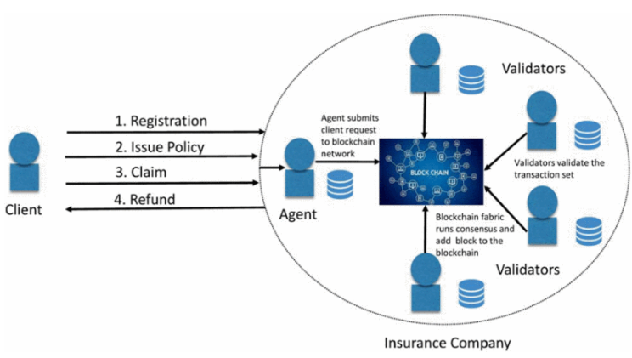

**Name:**  Yashvi Dhar **Class/Roll No: D17C/16**

What are the potential challenges and benefits of implementing blockchain-based cross-border payments systems? Discuss the role of smart contracts in automating and streamlining complex financial processes. Provide real-world examples.

Blockchain cross-border payments are money transfer transactions that take place between the parties from different countries and are settled with the help of the blockchain technology. Blockchain technology is often seen as a potential solution for cross-border payments, due to its ability to reduce costs, increase speed, and provide greater transparency. By eliminating the need for intermediaries, it can reduce fees and operational costs.

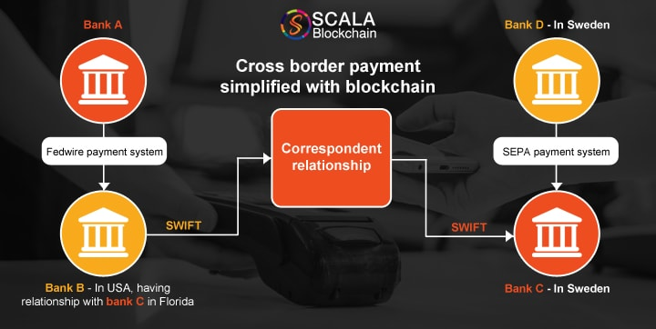

**Benefits of Blockchain based cross-border payments**

Increased Speed and Efficiency:

Blockchain technology enables near-instantaneous cross-border transactions, reducing the time it takes for funds to reach the recipient compared to traditional banking systems.

Reduced Costs:

Blockchain can potentially lower transaction costs by eliminating intermediaries, such as banks and clearinghouses. This could result in more affordable international transactions, especially for smaller businesses and individuals.

Enhanced Security:

Blockchain transactions are secured using cryptographic techniques. Once recorded, the data is immutable, meaning it cannot be easily altered. This enhances security and reduces the risks associated with fraud and data manipulation.

Transparency and Traceability:

Every transaction on a blockchain is recorded and can be traced back to its origin. This transparency can help reduce fraud and ensure accountability in the payment process.

Financial Inclusion:

Blockchain technology has the potential to provide financial services to individuals and businesses in regions with limited access to banking services, thereby promoting financial inclusion.

**Challenges**:

Compliance with Anti-Money Laundering Regulations:

Ensuring compliance with global and region-specific AML/CFT regulations, including KYC, CDD, and FATF requirements, to prevent illicit payments and money laundering.

High Cryptocurrency Volatility:

Addressing continuous and significant fluctuations in cryptocurrency prices, especially in the "fiat-crypto-fiat" model, to prevent loss of funds' value during currency conversion and transaction processing.

Continuous Data Upload from Off-chain Sources:

Seamless integration with external data sources to access payment-related documents and up-to-date currency exchange rates for accurate processing and recording of cross-border payment transactions.

Scalability and Throughput:

Overcoming limitations related to scalability and throughput in blockchain networks, especially during periods of high transaction volumes, to maintain efficiency and prevent delays and increased transaction fees.

Interoperability between Blockchains:

Ensuring seamless communication and compatibility between diverse blockchain networks involved in cross-border transactions, necessitating standardized protocols and interfaces for interoperability.

Legal and Jurisdictional Challenges:

Navigating complex legal frameworks and regulatory environments across different jurisdictions, determining applicable laws for transactions, dispute resolution, and compliance in international cross-border payments.

Security Concerns and Cyber Threats:

Mitigating security risks, including 51% attacks, double-spending, and smart contract vulnerabilities, to prevent manipulation of transactions and unauthorized access to funds.

Regulatory Uncertainty:

Dealing with varying regulations and lack of standardized frameworks, both globally and regionally, complicating cross-border transactions and compliance efforts.

Technical Complexity:

Overcoming technical challenges such as the scalability of blockchain networks, high energy consumption in proof-of-work systems, and complex algorithms and protocols.

Volatility and Speculation:

Managing the volatility and speculative nature of cryptocurrencies, which can lead to fluctuations in transaction value and liquidity, affecting the stability of cross-border payments.

Adoption and Trust:

Building trust among users and businesses in the security, reliability, and privacy of blockchain-based cross-border payment systems, and addressing the lack of understanding and awareness about blockchain technology.

Smart contracts on blockchain have the potential to streamline certain business processes. Business and IT leaders are looking at early use cases in advertising and healthcare, among others. Smart contracts technically can run on almost any digital platform, but they typically run on blockchain, which is a type of distributed ledger technology. Smart contracts are one of the most popular blockchain use cases, and for many, the term smart contract connotes smart contracts on blockchain.

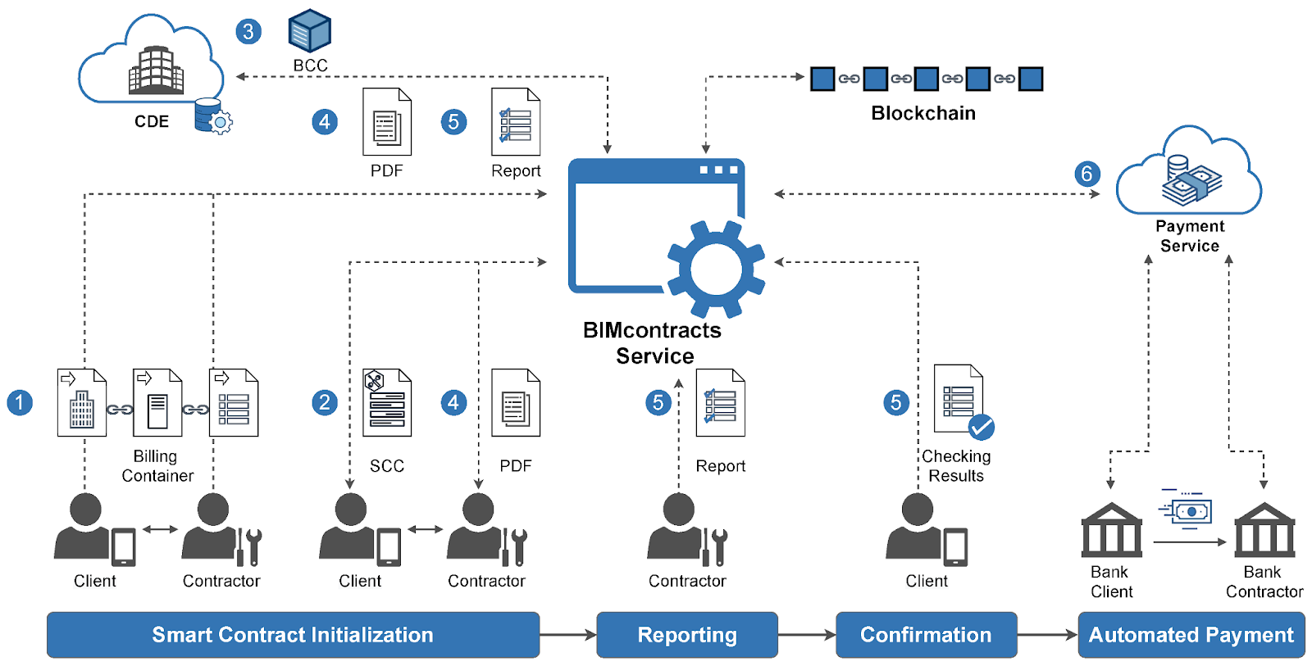

Smart contracts, powered by blockchain technology, play a crucial role in automating and streamlining complex financial processes. These self-executing contracts with coded terms and conditions enable automatic execution of transactions when predefined conditions are met. In the realm of finance, smart contracts offer several advantages, including transparency, security, efficiency, and reduced costs. Here's how they contribute to automating and streamlining complex financial processes, along with real-world examples:

1. Improving a digital advertising campaign

Smart contracts can potentially help advertisers and publishers build strong relationships. A smart contract could include conditions requiring a publisher to achieve predetermined targets. When an oracle confirms that the publisher has done what it was supposed to do, the smart contract triggers a payment. For example, a clause could stipulate that a social media account with a large following must promote a discount code. When there are 100 legitimate purchases that use the code, the owner of the social media account receives payment. In addition, smart contracts could prevent deceptive tactics like pixel stuffing or publishers overstating the impressions generated by an ad.

2. Building the best customer experience

Smart contracts can cultivate stronger B2C relationships. For example, a shoe brand partnering with a streaming music service offers complimentary subscription time if the consumer creates a playlist to listen to while jogging. A smart contract sends the customer an offer for a discount on new shoes or suggests songs with a similar tempo to add to the playlist.

3. Filling the void in entertainment consumption

Smart contracts on blockchain could improve how consumers interact with their preferred entertainment choices. For example, nonfungible tokens (NFTs) are a type of smart contract that authenticates ownership and streamlines the buying, selling and trading of digital entertainment assets. There is also interest in using smart contracts to pay independent creators such as authors, musicians and filmmakers. Smart contract automation would remove the need for intermediaries to process royalty payments.

4. Eliminating the go-between in financial transactions

Smart contract technology also enables decentralized finance (DeFi), which is most often associated with peer-to-peer transactions using cryptocurrencies like bitcoin and Ethereum's Ether. DeFi smart contracts could reduce the time and cost of settling these transactions. They also show promise in automating manual banking processes traditionally performed by financial institutions, such as evaluating loan eligibility and processing insurance claims.

5. Enhancing the healthcare communication pipeline

Clear communication is critical for both insurers and patients. Storing a patient's chart on a blockchain could potentially cut down on paperwork processing, improve regulatory compliance and simplify information sharing between providers. For example, if a patient needs a medical procedure, a prior authorization request could trigger a smart contract that reviews insurance coverage and releases payment to the provider.

6. Maximizing productivity in human resources

Distributed ledger technology could also automate HR workflows. HR staff often has to confirm employment histories and perform reference checks. Smart contracts could ease onboarding new employees by simplifying these verification tasks. In addition, smart contracts on blockchain could help enforce the terms of employment contracts and process payroll.

7. Boosting security for identity and access management

IT leaders must protect users' digital identities on corporate systems. Paperwork processing for manual identity requests isn't fast enough for a digitally dependent world. Persistent threats like data breaches show the need for new security options. Authenticating users via smart contracts could augment or replace conventional identity management procedures.

8. Elevating relationships in the insurance industry

Insurers and policyholders engage in multifaceted interactions, and the complex verbiage of insurance policies and fraudulent claim submissions by policyholders can sour the relationship. Smart contracts could improve efficiency in processing claims, make it easier for policyholders to switch carriers and foster cooperation between insurers. Smart contracts could also provide early detection of malicious actions.

9. Optimizing supply chain management

Certain parts of supply chain management could particularly benefit from smart contracts and blockchain. Smart contracts could increase the traceability of products and materials and address environmental, social and governance goals at the same time. For example, blockchain applications could track an item's origins as it moves between global supply chains and calculate tariffs in near real time. Some organizations are exploring smart contracts on blockchain as a way to improve efficiency and minimize errors.

10. Making energy distribution more efficient

Opportunities to use blockchain in the energy industry are growing. For example, blockchain software could automate electricity delivery from energy companies to customers. Smart contracts could streamline energy trading by connecting smaller energy producers. They could also certify renewable energy sources. Blockchain's ability to process and record transactions permanently makes its future in the energy industry promising.

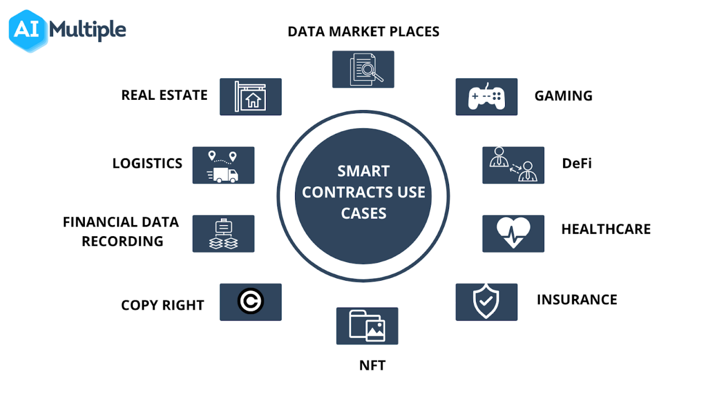

**Name:Aaditya Khetwani** **Class/Roll No: D17C/25**

Explain how blockchain can address issues of traceability and authenticity in global supply chains. Discuss the potential role of smart contracts in automating supply chain agreements and reducing disputes between parties. What challenges might arise when implementing blockchain in complex multi-party supply chain networks, and how can they be mitigated?

**ANS.** Blockchain technology has the potential to significantly improve traceability and authenticity in global supply chains. By creating a decentralized and transparent ledger of transactions, blockchain allows for the recording of every transaction or event in a supply chain process, providing an immutable and auditable record. This feature can greatly enhance traceability by allowing every participant in the supply chain to verify the origin and journey of products, thus ensuring authenticity and reducing the risk of counterfeit goods. Additionally, blockchain can improve transparency by providing real-time visibility into the movement and status of goods, which is crucial for maintaining the integrity of the supply chain.

Smart contracts, a key feature of blockchain technology, can play a pivotal role in automating supply chain agreements. Smart contracts are self-executing contracts with the terms directly written into code. They can automate various processes within a supply chain, such as payment processing, quality assurance, and delivery verification. By enabling automatic execution based on predefined conditions, smart contracts can streamline operations and reduce the need for intermediaries, thereby decreasing the potential for disputes between parties. These contracts can also enforce compliance with predefined rules, reducing the risk of fraudulent activities and enhancing trust among participants.

However, implementing blockchain in complex multi-party supply chain networks can pose several challenges:

Integration Complexity: Integrating blockchain technology with existing systems and processes can be complex and costly. Legacy systems might not easily integrate with blockchain, requiring significant changes to be made.

Scalability Issues: As supply chains involve a multitude of transactions and data, scalability can be a concern. Blockchain networks need to handle a high volume of transactions without compromising on speed and efficiency, which can be a challenge.

Data Privacy Concerns: While blockchain offers transparency, it can also raise data privacy concerns, especially in supply chains where sensitive information needs to be protected. Striking a balance between transparency and privacy is crucial.

Regulatory Challenges: Different regions have varying regulations and compliance requirements, making it challenging to implement a standardized blockchain solution across a global supply chain. Navigating these regulatory landscapes can be complex.

To mitigate these challenges, supply chain stakeholders can consider the following strategies:

Pilot Programs and Testing: Starting with pilot programs can help in understanding the practical implications and challenges of implementing blockchain technology in a supply chain, allowing for adjustments and optimizations before full-scale implementation.

Collaboration and Standardization: Collaboration among supply chain partners and industry stakeholders can facilitate the development of standardized protocols and frameworks for blockchain implementation, promoting interoperability and compatibility across different systems and networks.

Scalability Solutions: Investing in scalable blockchain solutions, such as sharding and sidechains, can help address the issue of scalability, ensuring that the blockchain network can handle a large volume of transactions without compromising speed and efficiency.

Data Privacy Measures: Implementing encryption techniques and permissioned blockchains can enhance data privacy and security, allowing for selective access to sensitive information while maintaining overall transparency within the supply chain network.

Regulatory Compliance and Governance: Working closely with regulatory bodies and establishing governance frameworks that comply with regional regulations can help address regulatory challenges, ensuring that blockchain implementation aligns with legal requirements and standards.

By addressing these challenges proactively and adopting a collaborative approach, supply chain stakeholders can harness the potential of blockchain technology to improve traceability, enhance authenticity, and streamline operations in global supply chains.

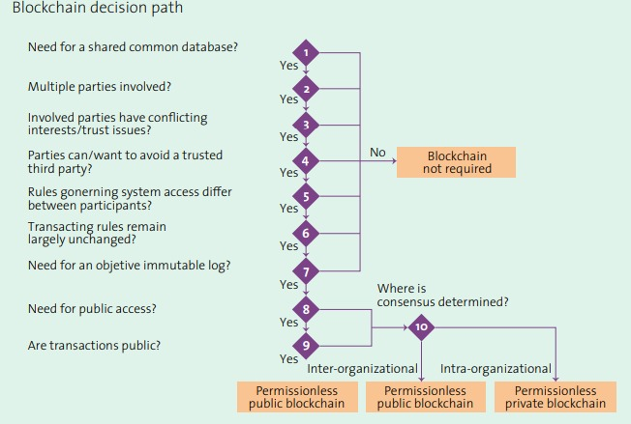

**Name: Khusboo Harpal Kimtani**   **Class/Roll No: D17C/26**

Explain the concept of patient-controlled health data access through blockchain. What are the implications for patient privacy and data security? Describe how blockchain can streamline the process of healthcare payments pre-authorization, improving accuracy and reducing delays.

**Patient-Controlled Health Data Access through Blockchain:**

**Concept**:

At its core, the idea involves allowing patients to have control over who can access their health records.

Instead of medical institutions owning and controlling health data, it is stored on a blockchain, giving patients the ability to provide and revoke access to specific parts of their medical records.

**Working:**

The patient's health data is encrypted and stored on a decentralized blockchain.

Each patient possesses a private key, which they can use to grant access to specific parts of their health records.

Medical practitioners or institutions can request access to these records.

Patients can approve or deny these requests based on their own discretion.

**Implications for Patient Privacy and Data Security**:

Enhanced Patient Privacy: The decentralization means that there's no single point of control, reducing the risk of unauthorized access. Patients have full authority over their data, deciding who can or cannot access specific portions of their records.

Data Security: Data on the blockchain is encrypted, which adds a layer of security. Additionally, since blockchain data is stored across multiple nodes or computers, it's harder for malicious entities to alter or delete the information without being detected.

Potential Challenges: However, like all technologies, this isn't without potential pitfalls. Storing large amounts of health data on a blockchain could face scalability issues. Additionally, while blockchain ensures data integrity, if someone loses their private key, they could potentially lose access to their own health records.

**Streamlining Healthcare Payments Pre-authorization through Blockchain:**

**Concept**:

Pre-authorization in healthcare refers to getting approval from health insurance companies before certain medical services are provided to ensure they will be covered.

Blockchain can automate and secure this process.

**Working:**

Medical institutions could submit pre-authorization requests to insurers via smart contracts on the blockchain.

Smart contracts are self-executing contracts with the terms of the agreement between parties directly written into lines of code.

The insurer's response (approved/denied) would be stored on the blockchain, ensuring transparency and immutability.

The decentralized nature would remove intermediaries, speeding up the process.

**Benefits**:

Accuracy: Since the rules of the smart contract are predefined and self-executing, errors due to human intervention are minimized.

Reduced Delays: Automation and the removal of intermediaries can significantly reduce the time needed for pre-authorizations.

Transparency: Both parties can track the status of pre-authorizations in real-time.

**Conclusion:**

In conclusion, blockchain has the potential to revolutionize many aspects of healthcare by ensuring patient data privacy, enhancing security, and streamlining administrative processes. However, like all technologies, its implementation would require careful consideration of potential challenges and rigorous security measures.

**Name:** Vishakha Kulkarni **Class/Roll No: D17C/29**

Discuss the role of smart contracts in automating the validation and authorization of medical procedures for insurance claims. What challenges might arise in integrating blockchain-based payment pre-authorization systems with existing healthcare IT infrastructure?

**Role of Smart Contracts in Automating Medical Procedure Validation and Authorization:**

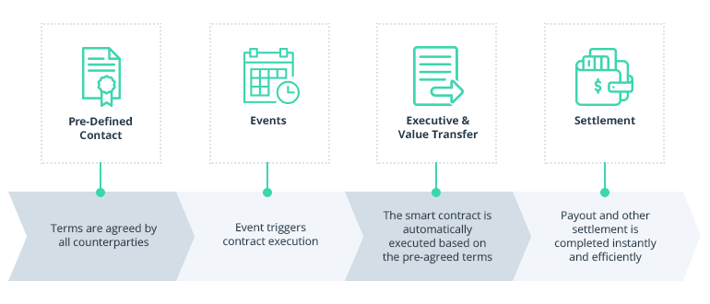

Smart contracts can transform the validation and authorization of medical procedures for insurance claims in several ways:

Automated Verification: Smart contracts can instantly verify the eligibility of a patient's insurance coverage for a specific medical procedure. They can check policy details, deductibles, co-pays, and coverage limits to determine whether the procedure is authorized.

Real-time Decision-Making: By relying on predefined rules and data available on the blockchain, smart contracts make real-time decisions regarding authorization. This eliminates the need for manual reviews and expedites the process.

Transparency: Smart contracts operate on a transparent and immutable blockchain. All stakeholders, including patients, healthcare providers, and insurers, can access and verify the terms of the contract, ensuring trust and transparency in the authorization process.

Cost Reduction: Automation through smart contracts reduces administrative overhead, minimizes the risk of errors, and lowers the cost associated with manual claims processing and validation.

Security: Patient data and insurance information can be securely stored on the blockchain, enhancing data security and privacy. Access controls ensure that only authorized parties can view sensitive information.

Efficient Payment Processing: Once a medical procedure is authorized, smart contracts can automatically trigger payment to the healthcare provider. This reduces delays in reimbursement and ensures timely payments.

Fraud Prevention: The transparency and immutability of blockchain data make it challenging for fraudulent claims to go undetected. Duplicate claims and unauthorized procedures can be quickly identified.

**Challenges in Integrating Blockchain-Based Payment Pre-Authorization Systems with Healthcare IT Infrastructure:**

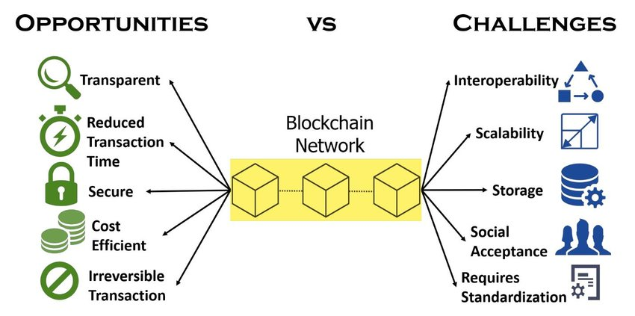

Legacy Systems: Many healthcare institutions use legacy IT systems that are not compatible with blockchain technology. Integrating blockchain-based pre-authorization systems with these systems can be complex and costly.

Data Standardization: Data standardization is essential for interoperability between blockchain systems and existing healthcare IT infrastructure. Ensuring that data formats align with industry standards is crucial.

Regulatory Compliance: The healthcare industry is highly regulated, with strict rules regarding data privacy (HIPAA in the U.S.) and insurance practices. Blockchain-based systems must comply with these regulations, which may require adjustments to the technology.

Scalability: As healthcare data can be vast and complex, ensuring that blockchain networks can scale to handle the volume of data generated by medical procedures and insurance claims is a challenge.

User Adoption: Healthcare professionals, insurers, and patients may not be familiar with blockchain technology. Training and education are necessary to ensure widespread adoption and effective use of blockchain-based systems.

Integration Costs: The initial costs of integrating blockchain technology with existing IT infrastructure can be substantial. Organizations must weigh the long-term benefits against these upfront expenses.

Data Migration: Transferring existing healthcare data to a blockchain-based system can be time-consuming and prone to errors. Data migration strategies need to be carefully planned and executed.

Interoperability: Achieving interoperability between different blockchain networks and healthcare providers' systems is crucial for a seamless ecosystem. Standards for interoperability need to be established.

Consensus Mechanisms: Selecting the appropriate consensus mechanism for a healthcare blockchain network is essential. The chosen mechanism must balance security, performance, and energy efficiency.

**Name:**  **Aarya Lotke Class/Roll No: D17C/30**

Explain the synergy between blockchain technology and the Internet of Things (IoT) in terms of data integrity, security, and decentralized data exchange. Discuss the potential challenges and solutions when implementing blockchain for secure and trustworthy IoT data sharing.

The synergy between blockchain technology and the Internet of Things (IoT) holds tremendous promise for enhancing data integrity, security, and decentralized data exchange. Following are the points :

1. Data Integrity:

Immutable Ledger: Blockchains provide a tamper-proof and immutable ledger. When IoT devices record data on a blockchain, it cannot be altered or deleted without consensus from the network participants. This ensures the integrity of data generated by IoT devices.

Timestamping: Each transaction on a blockchain is timestamped and linked to the previous one, creating a chronological record. IoT data, especially in applications like supply chain management or environmental monitoring, can benefit from this precise timestamping to track events accurately.

2. Security:

Decentralized Trust: Traditional centralized systems are vulnerable to single points of failure and hacking. In contrast, blockchain's decentralized architecture means that no single entity controls the network. This makes it extremely difficult for malicious actors to manipulate data or attack the network.

Cryptography: Blockchain relies on cryptographic techniques to secure transactions. When IoT devices communicate with the blockchain, data can be encrypted and verified cryptographically. This adds an extra layer of security to IoT data.

3. Decentralized Data Exchange:

Peer-to-Peer Transactions: Blockchain enables direct peer-to-peer transactions between IoT devices, removing the need for intermediaries. Devices can autonomously exchange data and execute smart contracts, enhancing the efficiency of IoT ecosystems.

Interoperability: Different IoT devices and platforms can use a common blockchain network to exchange data. This interoperability fosters seamless communication among various devices and systems, creating a unified IoT ecosystem.

Potential Challenges and Solutions:

Scalability: Blockchains like Bitcoin and Ethereum face scalability issues, which can hinder their use in IoT applications where millions of devices generate data. Solutions include using blockchain platforms designed for scalability (e.g., EOS, IOTA) or implementing off-chain solutions that periodically anchor data onto the main blockchain.

Energy Efficiency: Proof-of-work (PoW) blockchains, like Bitcoin, consume substantial energy. Transitioning to energy-efficient consensus mechanisms, such as Proof-of-Stake (PoS) or Directed Acyclic Graph (DAG), can mitigate this issue.

Latency: IoT devices often require low-latency responses. Blockchains' confirmation times may not meet these requirements. One solution is to use permissioned blockchains with faster consensus algorithms, or layer-2 solutions like state channels or sidechains for real-time data exchange.

Data Privacy: Public blockchains store data publicly, which might not be suitable for sensitive IoT data. Private and consortium blockchains, which restrict access to authorized parties, can address privacy concerns.

Cost: Transaction fees on public blockchains can be cost-prohibitive for small IoT transactions. Leveraging blockchain as a settlement layer and using off-chain mechanisms for microtransactions can help reduce costs.

Security Risks: While blockchain enhances security, the security of IoT devices themselves is crucial. Ensuring that IoT devices are protected against physical and digital threats is essential to maintaining the overall security of the system.

Regulatory Compliance: Adhering to data privacy regulations (e.g., GDPR) while using blockchain for IoT data is essential. Implementing features like data anonymization and consent management can help comply with these regulations.

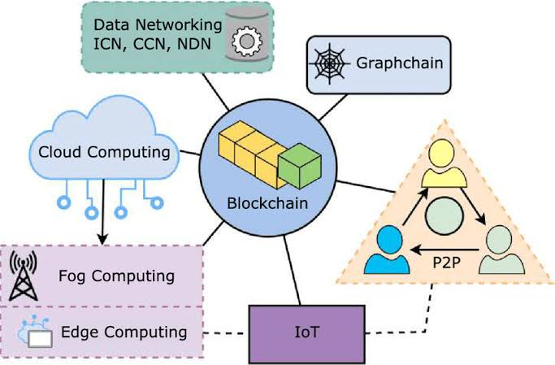

In conclusion, the synergy between blockchain and IoT offers a robust framework for enhancing data integrity, security, and decentralized data exchange. However, it is essential to carefully select the appropriate blockchain technology, address scalability and latency issues, and ensure compliance with relevant regulations to fully realize the potential benefits while overcoming the associated challenges.

**Module - 3 : Programming for Blockchain**

**Name:**  **Neeta Narang** **Class/Roll No: D17B/45**

**Q8.**  Explain in short string data type, types of arrays, Enums and Struct data type, mappings and how it is created in Solidity. Explain each with an example.

**Strings:-**

Strings in Solidity is a reference type of data type which stores the location of the data instead of directly storing the data into the variable. They are dynamic arrays that store a set of characters that can consist of numbers, special characters, spaces, and alphabets. Strings in solidity store data in UTF-8 encoding. Both Double quote("") and Single quote(‘’) can be used to represent strings in solidity. Strings in Solidity is a data type used to store a set of characters.

**Example:-** string public greeting = "Hello World!";

**Arrays :-**

Arrays are data structures that store the fixed collection of elements of the same data types in which each and every element has a specific location called index. In Solidity, an array can be of fixed size or dynamic size. Arrays have a continuous memory location, where the lowest index corresponds to the first element while the highest represents the last.

**Types of Arrays :-**

**Fixed-size Arrays**

The size of the array should be predefined. The total number of elements should not exceed the size of the array. If the size of the array is not specified then the array of enough size is created which is enough to hold the initialization.

**Example :-** uint[] data = [10, 20, 30, 40, 50];

**Dynamic Arrays:**

The size of the array is not predefined when it is declared. As the elements are added the size of array changes and at the runtime, the size of the array will be determined.

**Example :** uint[] public dynamicArray;

dynamicArray.push(10);

dynamicArray.push(20);

**Enums:**

Enums are the way of creating user-defined data types, it is usually used to provide names for integral constants which makes the contract better for maintenance and reading. Enums restrict the variable with one of a few predefined values, these values of the enumerated list are called enums. Options are represented with integer values starting from zero, a default value can also be given for the enum. By using enums it is possible to reduce the bugs in the code.

**Example :-** enum State { Pending, Approved, Rejected }

State public currentState = State.Pending;

**Struct :**

Structs in Solidity allows you to create more complicated data types that have multiple properties. You can define your own type by creating a struct. They are useful for grouping together related data.

Structs can be declared outside of a contract and imported in another contract. Generally, it is used to represent a record. To define a structure struct keyword is used, which creates a new data type.

**Example :-** struct Person {

    string name;

    uint age;

}

Person public alice = Person("Alice", 30);

**Mappings :-**

Mapping in Solidity acts like a hashtable or dictionary in any other language. These are used to store the data in the form of key-value pairs, a key can be any of the built-in data types but reference types are not allowed hile the value can be of any type. Mappings are mostly used to associate the unique Ethereum address with the associated value type.

**Example :-** mapping(address => uint) public balances;

function deposit() public payable {

    balances[msg.sender] += msg.value;

}

In the example above, the mapping balances associates an Ethereum address with a balance. The deposit function allows users to deposit Ether into their accounts.

**Module - 3 : Programming for Blockchain**

**Name:**  **Neeta Narang** **Class/Roll No: D17B/45**

**Q9.** Explain in short different function visibility and qualifiers; Address and Address Payable,  constructor.  Explain each with an example.

In Solidity, functions can have different visibility and qualifiers, and there are special data types like address and address payable, as well as constructors.

**Function Visibility and Qualifiers:**

**1. Public:** Functions declared as public can be accessed from within the contract and externally. They generate a public getter function for the state variable.

**Example :-** contract VisibilityExample {

       uint publicValue;

       function setPublicValue(uint _value) public {

           publicValue = _value;

       }

   }

**2. Internal:-** Functions declared as internal can only be accessed within the current contract and its derived contracts.

**Example :-** contract VisibilityExample {

       uint internalValue;

       function setInternalValue(uint _value) internal {

           internalValue = _value;

       }

   }

**3. Private:** Functions declared as private can only be accessed from within the current contract.

**Example :-**  contract VisibilityExample {

       uint privateValue;

       function setPrivateValue(uint _value) private {

           privateValue = _value;

       }

   }

**4. External:** Functions declared as external can only be called externally (from other contracts). They are often used for contract-to-contract communication.

**Example :-**    contract VisibilityExample {

       function someExternalFunction() external pure returns (uint) {

           return 42;

       }

   }

**Address and Address Payable:**

**1. Address:** address is a data type used to store Ethereum addresses. It can send and receive Ether but cannot call other contract functions directly.

**Example :-** address public owner = msg.sender;

**2. Address payable:** Address payable is a data type that extends address and can be used to send Ether as well as call functions in other contracts.

**Example :-**address payable public receiver = payable(0x123...); // An example Ethereum address

**3. Constructor:** The constructor is a special function in a Solidity contract that is executed only once when the contract is deployed. It is used to initialize contract state variables and perform setup tasks.

**Example :-**   contract ConstructorExample {

       uint public value;

       constructor(uint _initialValue) {

           value = _initialValue;

       }

   In this example, the constructor sets the initial value of `value` when the contract is deployed.

**Name : Tammana Bathija**

**Class:D17C/06**

**MODULE - 6**

**Q3 - Discuss the potential advantages and concerns of using blockchain for tracking pharmaceutical supply chains and preventing counterfeit drugs.**

Blockchain technology has a number of potential benefits and can address significant issues in the pharmaceutical industry while tracking pharmaceutical supply chains and preventing the sale of fake medications. Here is an explanation of these benefits and issues, along with appropriate illustrations to highlight the main points:

Benefits of Blockchain Technology:

Transparency: A blockchain-based ledger that records every transaction in the supply chain is transparent and unchangeable. All stakeholders, including regulators, manufacturers, distributors, and customers, are able to access up-to-date information regarding the flow of pharmaceuticals because to this transparency.

Data Privacy: Although blockchain technology is safe, worries concerning the confidentiality of private medical information must be taken care of. Data handling may be impacted by regulations like GDPR.

Scalability: Given how much data pharmaceutical supply chains handle, scalability of blockchain networks may be an issue. We must investigate alternatives like sidechains and sharding

Regulatory Compliance: It's crucial to guarantee regulatory compliance while utilising blockchain technology in the pharmaceutical industry. Regulators must change to fit the new paradigm.

Costs: Putting blockchain solutions into use and keeping them up to date can be expensive. Businesses must compare the costs of improved security and transparency to the advantages.

In conclusion, by improving transparency, traceability, and security in pharmaceutical supply chains, blockchain technology has the potential to revolutionise those systems. Nevertheless, addressing issues with integration, privacy,and regulatory compliance is essential for the successful adoption of blockchain in the pharmaceutical industry.

**Q4-How can blockchain-based IoT networks improve device management, data monetization, and user privacy in the rapidly growing IoT ecosystem?**

Benefits of Blockchain for IoT -

User

In the quickly expanding IoT ecosystem, how might blockchain-based IoT networks enhance device management, data monetization, and user privacy?

In the quickly expanding IoT environment, ChatGPT Blockchain-based IoT networks can provide a number of advantages in terms of device control, data monetization, and user privacy:

Enhanced Security: The security of IoT devices and data is guaranteed by blockchain's decentralized and encrypted nature. Data is encrypted on each device, giving each one a distinct identity and lowering the possibility of tampering and unwanted access.

Device authentication: Blockchain technology can offer a safe method of IoT device authentication, ensuring that only authorized devices can connect to the network. As a result, spoofing and unwanted access are avoided.

Data Integrity: Blockchain keeps a tamper-proof ledger of all transactions. By preventing hostile actors from changing or deleting data without network agreement, this maintains data integrity.

Smart Contracts: By automating device management processes like firmware updates, device provisioning, and access control, smart contracts eliminate the need for centralized middlemen.

IoT devices generate enormous volumes of data, which can be monetized. By giving access to certain parties through smart contracts and assuring fair pay and control over data sharing, blockchain enables device owners to securely monetise their data.Control over privacy: Blockchain-based technologies provide individuals more power over their data. Users' privacy is improved since they can define who has access to their data and under what circumstances.

Blockchain can clearly establish who owns data created by IoT. When numerous parties are involved in data collecting and sharing, this is very crucial.

Scalability: The decentralized nature of blockchain allows it to easily handle the rising number of devices and transactions as the IoT ecosystem expands.

Transparency and trust: Blockchain's transparent ledger adds a degree of confidence to IoT networks. Users and companies may validate the legitimacy of data and transactions, fostering ecosystem trust.

Although blockchain has many benefits, it also has drawbacks, including scalability issues, energy consumption issues (proof-of-work networks), and the requirement for consensus methods. Blockchain-based IoT network implementation should be done carefully, taking into account these characteristics and particular use-case needs.  
  
**NAME: DIVESH MANGTANI CLASS: D17C / 34**

**Module - 1  : Introduction to Blockchain  
Q9) How public key cryptography plays a role in the security of blockchain? Explain with examples. What is hash and how it provides security in blockchain? Explain.**

Public key cryptography and hash functions play essential roles in the security of blockchain technology

Public key cryptography is a type of cryptography that uses two keys: a public key and a private key. Public key cryptography is used in blockchain to secure transactions and to provide authentication for users. For example, when a user creates a transaction, they digitally sign the transaction with their private key. This signature can then be verified by anyone using the user's public key. This ensures that the transaction was created by the legitimate user and that it has not been tampered with.

Hash functions

A hash function is a mathematical function that takes an input of any size and produces a fixed-size output. Hash functions are designed to be irreversible, meaning that it is impossible to calculate the input from the output.

Hash functions are used in blockchain to secure blocks and to link blocks together to form the blockchain. When a block is created, the miner calculates a hash of the block header. The block header contains information about the block, such as the previous block hash, the timestamp, and the merkle root. The miner then includes the block hash in the block.

When a new block is created, the miners verify the block by calculating the hash of the block header and comparing it to the block hash included in the block. If the two hashes match, then the block is considered to be valid.

Examples of how public key cryptography and hash functions are used in blockchain

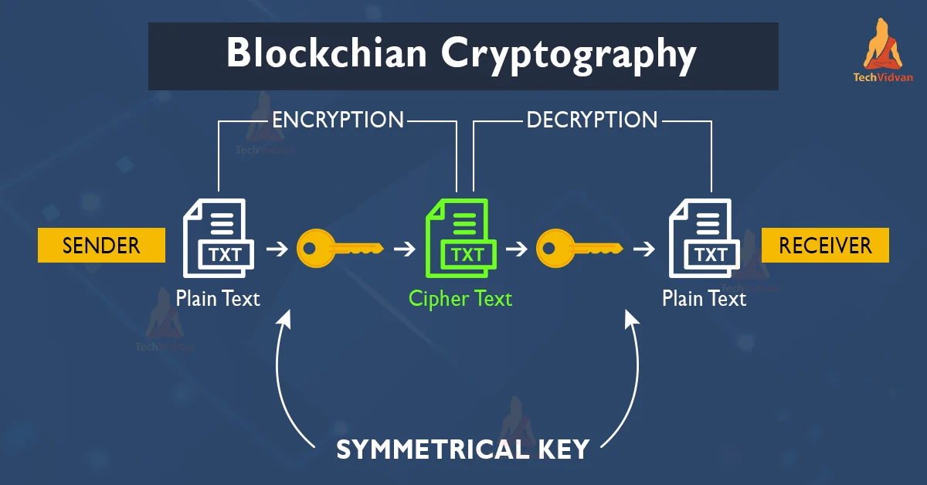

Here are some examples of how public key cryptography and hash functions are used in blockchain:

Transaction security: Public key cryptography is used to secure transactions by digitally signing them with the sender's private key. This ensures that the transaction was created by the legitimate user and that it has not been tampered with.

Authentication: Public key cryptography is used to provide authentication for users. When a user creates a blockchain account, they generate a public key and a private key. The user's public key is used to identify them on the blockchain, and their private key is used to digitally sign transactions and messages.

Block security: Hash functions are used to secure blocks by calculating a hash of the block header. This hash is included in the block, and it is used to verify the block when it is added to the blockchain.

Blockchain integrity: Hash functions are used to link blocks together to form the blockchain. The block header of each block includes the hash of the previous block. This means that if an attacker tries to modify a block, they will also need to modify all of the subsequent blocks in the blockchain. This is very difficult to do without being detected.

**10) What are Merkle trees ? Explain the structure of a Merkle tree. What are the advantages of the Merkle tree? How does the Merkle tree ensure security in blockchain? Explain in detail with examples.**

**Merkle trees**

Merkle trees, also known as hash trees, are a data structure that allows for efficient and secure verification of large amounts of data. They are used in a variety of applications, including blockchain technology.

**Structure of a Merkle tree**

A Merkle tree is a binary tree, meaning that each node has two child nodes. The leaves of the tree contain the data that is being verified. The internal nodes of the tree contain hashes of the child nodes.

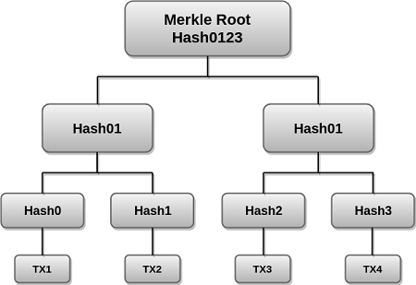

**Advantages of Merkle trees**

Merkle trees offer a number of advantages, including:

Efficiency: Merkle trees allow for efficient verification of large amounts of data. This is because only the Merkle root needs to be verified, rather than all of the individual data items.

Security: Merkle trees are secure because they are tamper-proof. If any of the data items in the tree are modified, the Merkle root will change. This means that it is impossible to modify the data without being detected.

Merkle trees are used in blockchain to ensure the security of transactions and blocks.

**Transactions:**

Each transaction in a blockchain block is hashed. These hashes are then combined to form a Merkle tree. The Merkle root is then included in the block header.When a new block is mined, the miners verify all of the transactions in the block by calculating the Merkle root and comparing it to the Merkle root included in the block header. If the two Merkle roots match, then all of the transactions in the block are considered to be valid.

**Blocks:**

The block header of each block in a blockchain contains the hash of the previous block. This means that all of the blocks in a blockchain are linked together.If an attacker tries to modify a block in the blockchain, they will also need to modify all of the subsequent blocks in the blockchain. This is very difficult to do without being detected.

Example

Alice wants to send 1 BTC to Bob.

Alice creates a transaction and signs it with her private key.

The transaction is broadcast to the network.

Miners collect transactions and bundle them into blocks.

Miners calculate the Merkle root of the transactions in the block.

Miners include the Merkle root in the block header.

Miners compete to solve a complex mathematical puzzle to mine the block.

Once a block is mined, it is broadcast to the network.

Nodes verify the block by calculating the Merkle root of the transactions in the block and comparing it to the Merkle root included in the block header.

If the two Merkle roots match, then all of the transactions in the block are considered to be valid.

**NAME : PRATIK SAWLANI CLASS : D17C / 64**

**MODULE 3**

Q2) Explain working of smart contracts with examples. Explain different types of smart contracts.

On the blockchain, smart contracts serve as self-executing contracts. They essentially operate like computer programs when specific criteria are satisfied. This implies that they can automate agreements and transactions without the need for middlemen.

Here's an easy illustration:

Think about wanting to purchase a car online. The conditions of the sale could be established using a smart contract. You could decide, for instance, that the vendor won't get paid until you've gotten the car. Once you've verified that you've received the car, the smart contract will automatically release the money to the seller.

This does away with the requirement for a reliable third party, such a bank or an escrow company. Additionally, it speeds up the transaction.

Smart contracts are still a relatively new technology, but they have the potential to revolutionise many different industries. As the technology continues to develop, we can expect to see even more innovative and exciting applications for smart contracts in the future.

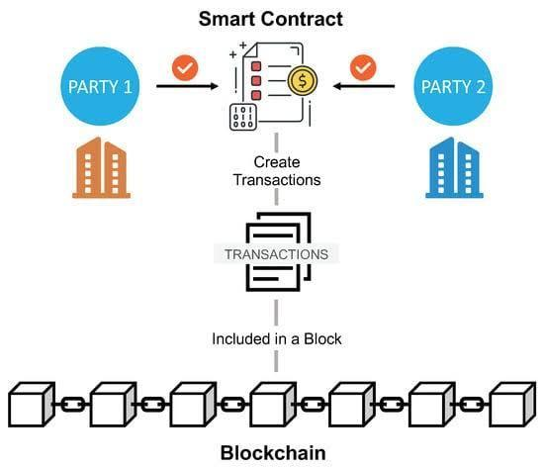

Smart contracts are self-executing contracts whose contract terms are written directly into the  code. They run on blockchain platforms like Ethereum and are automatically triggered when predefined conditions are met. There are different types of smart contracts, each designed for specific use cases. Here are some of the more common types.

 1. Payment Agreements:

 - These contracts facilitate the transfer of digital assets, such as cryptocurrency, from one party to another when certain conditions are met. Payment contracts are often used for financial transactions, including booking services and recurring payments.

 2. Token Contracts:

 - Token contracts are used to create and manage digital tokens on blockchain platforms. These tokens can represent a variety of resources, including utility tokens, security tokens, and non-fungible tokens (NFTs). ERC-20, ERC-721, and ERC-1155 are popular standards for Ethereum token contracts.

3. Conservation agreements:

 - Escrow agreements hold money or funds until predetermined conditions are met. For example, in online marketplaces, an escrow agreement may arrange payment until the buyer receives the purchased goods or services.

  4. Multi-signal Agreements:

 - Multi-signal (multi-signal) contracts require several parties to sign  a transaction before it is executed. They are often used for security purposes to prevent unauthorized access or misuse of funds. Multisig wallets are a common application for this type of contract.

  5. DAOs (Decentralized Autonomous Organizations):

 - DAO contracts represent organizations governed by codes and rules defined in the contract itself. Brand owners can participate in decision-making  by voting on proposals. DAOs are used for decentralized governance and decision making.

 6. Supply chain agreements:

 - Supply chain contracts help improve transparency and traceability of supply chain management. They enable the tracking and authentication of goods as they move through the supply chain, reducing fraud and errors.

  7. Oracle Agreements:

 - Oracle contracts connect the blockchain to external data sources. They are used to take real information such as prices, events or weather conditions and make that information available to other smart contracts. Oracle plays a key role in distributed applications (DApps).

  8. Game contracts:

 - These contracts govern in-game resources, items and interactions in distributed games. They can create, own and transfer  in-game resources as well as game mechanics and rules.

  9. Insurance contracts:

 - Smart contracts are used to create and manage insurance policies. When predefined conditions (such as flight cancellations or accidents) are met, the contract automatically processes claims and compensation.

 10. Real estate contracts:

 - With the help of smart contracts, the purchase and sale of real estate can be simplified by automating the processes of transfer of ownership of real estate, proof of ownership and payment processing.

 11. Content License Agreements:

 - These agreements govern the use and licensing of digital content such as music, videos and images. They allow content creators to define  terms of use for  their work and automatically enforce them.

 12. Gambling and Wagering Agreements:

 - Smart contracts can be used to create decentralized gaming and betting platforms that enable transparent and fair games without  intermediaries.

 13. Voting agreements:

 - Voting contracts enable secure and open voting processes. They can be used for elections, DAO management and decision making in various organizations.

 Each type of smart contract serves a specific purpose and can be customized to meet the requirements of different industries and use cases. Their ability to automate processes, increase transparency and reduce the need for intermediaries has made them a powerful tool in the world of blockchain technology.

Q3) Write a short note on Smart Contracting Devices (SCD).

Smart Contracting Devices (SCDs) are physical devices that can execute smart contracts. They are typically equipped with sensors, actuators, and processors that allow them to interact with the physical world and execute smart contracts based on real-world events.

SCDs have a wide range of potential applications, including:

Supply chain management: SCD can be used to track the movement of goods through a supply chain and automatically trigger payments or other actions when certain conditions are met.

IoT: SCD can be used to connect and manage IoT devices and automate interactions between them.

Manufacturing: SCD can be used to automate manufacturing processes and ensure that products meet quality standards.

Real estate: SCD can be used to automate the purchase, sale, and rental of real estate.

Insurance: SCD can be used to automate the payment of insurance claims.

SCDs are still a relatively new technology, but they have the potential to revolutionize many different industries. As the technology continues to develop, we can expect to see even more innovative and exciting applications for SCD in the future.

Here are some of the potential benefits of using SCD:

Increased efficiency: SCD can automate many tasks that are currently performed manually, which can lead to significant efficiency gains.

Reduced costs: SCD can help to reduce costs by eliminating the need for intermediaries and automating many manual tasks.

Improved transparency: SCD can help to improve transparency in supply chains and other business processes by providing real-time visibility into data and transactions.

Reduced risk: SCD can help to reduce risk by automating complex tasks and ensuring that contracts are executed correctly.

Overall, SCD has the potential to make businesses more efficient, cost-effective, transparent, and secure.

Example: Smart thermostat: A smart thermostat can be used to automate the temperature of a home or building. The thermostat can be programmed to adjust the temperature based on the time of day, the weather conditions, and the occupancy of the building. The thermostat can also be used to make payments to energy suppliers automatically.

Smart lock: A smart lock can be used to control access to a building or room. The lock can be unlocked using a smartphone app, a fingerprint scanner, or a facial recognition system. Smart locks can also be used to grant access to different people at different times of day.

Smart meter: A smart meter can be used to track the energy consumption of a home or building. The data collected by the smart meter can be used to generate bills, identify energy saving opportunities, and automate payments to energy suppliers.

Agricultural sensors: Agricultural sensors can be used to monitor the condition of crops and livestock. The data collected by the sensors can be used to automate tasks such as irrigation, fertilization, and pest control. The sensors can also be used to track the movement of agricultural products through the supply chain.

**NAME : GAURAV AMBARTANI CLASS : D17C / 02**

**MODULE 5**

Q13) Explain working of Hyperledger fabric. How to create a Hyperledger network.

Hyperledger Fabric operates using a few key concepts:

**Network Participants:** Fabric is designed for permissioned networks, meaning that only authorized participants can join the network. Participants are typically organizations or entities that have a vested interest in the network and its transactions.

**Channels:** Fabric allows the creation of multiple channels within a network. Each channel is a private sub-network that can have its own set of participants and transactions. This enables confidential transactions between a subset of participants.

**Chaincode (Smart Contracts):** In Fabric, smart contracts are referred to as "chaincode." Chaincode is a piece of code that defines the business logic and rules for transactions. It can be written in programming languages like Go, Node.js, or Java. Chaincode is installed and instantiated on the network and can be upgraded without disrupting the entire network.

**Consensus Mechanism:** Hyperledger Fabric uses a modular consensus mechanism that allows network participants to choose a consensus protocol that suits their needs. This flexibility enables different consensus algorithms, such as Practical Byzantine Fault Tolerance (PBFT) and Raft, to be used within the same network.

**Ledger:** Fabric maintains two ledgers: the World State and the Transaction Log. The World State is a snapshot of the current state of the ledger, while the Transaction Log records all transactions in a tamper-evident manner.

**Identity and Access Management:** Fabric employs a robust identity and access management system to control which participants can perform specific actions on the network, ensuring security and privacy.

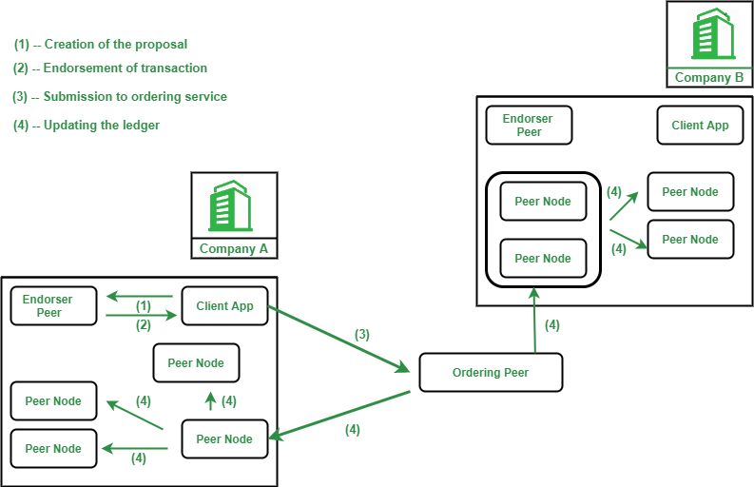

Q14) State various use cases where hyperledger is used.

**Supply Chain Management:** Hyperledger Fabric is widely adopted for tracking and tracing products in supply chains. It enables transparency, reduces fraud, ensures the authenticity of products, and provides a tamper-proof ledger for documenting the movement of goods.

**Trade Finance:** It is used to streamline trade finance processes, including letter of credit, invoice financing, and document verification. Fabric can facilitate secure and efficient international trade transactions.

**Healthcare:** Hyperledger Fabric can be used to maintain secure and interoperable healthcare records, ensuring that patient data is accessible to authorized parties while protecting patient privacy.

**Financial Services:** In the financial sector, Fabric is used for applications such as cross-border payments, securities trading, and identity verification. It helps reduce settlement times, fraud, and operational costs.

**Identity and Access Management:** Fabric can be used to create secure and decentralized identity management systems. Users can have control over their personal data and selectively share it with trusted parties.

**Voting Systems:** Hyperledger Fabric has been explored for creating secure and transparent voting systems. It can enhance the integrity and auditability of election processes.

**Provenance and Authenticity:** Industries like luxury goods, art, and wine use Fabric to authenticate the provenance and authenticity of products. This helps combat counterfeiting.

**Insurance:** Fabric can simplify the insurance claims process by providing a transparent and immutable ledger of policy information and claims history.

**Real Estate:** It can be used for property title management, reducing fraud and errors in real estate transactions. Smart contracts can automate property transfer processes.

**Food Safety:** Hyperledger Fabric can track the production and distribution of food products, helping to quickly identify and address food safety issues.

**ANISHKUMAR IYER  D17C 03**

**M6 Q1:**

**How can blockchain help in providing secure and verifiable digital identities for citizens, and**

**what are the implications for government services?**

Blockchain technology can play a crucial role in providing secure and verifiable digital identities

for citizens, offering several advantages over traditional identity management systems. Here's

how blockchain can contribute to this and the implications for government services:

1. Decentralization and Security:

- Immutable Records: Blockchain provides an immutable and tamper-resistant ledger where

identity information is stored. Once data is recorded, it cannot be altered or deleted, ensuring

the integrity of citizens' digital identities.

- Encryption and Security Protocols: Blockchain networks employ advanced cryptographic

techniques to secure data. This enhances the overall security of digital identities by protecting

sensitive information.

2. User Control:

- User-Centric Identity: Citizens can have greater control over their digital identities. They can

choose what information to share and with whom, reducing the risk of unauthorized access and

misuse of personal data.

- Consent Mechanisms: Smart contracts on the blockchain can enable citizens to give explicit

consent before their identity information is accessed or shared.

3. Interoperability:

- Standardization: Blockchain can facilitate the creation of standardized protocols for identity

management. This can enhance interoperability between different systems and services,

making it easier for government agencies to adopt and implement secure identity solutions.

4. Reduced Identity Theft:

- Immutable Verification: The immutability of blockchain records makes it extremely difficult for

malicious actors to alter or forge identities. This reduces the risk of identity theft, as citizens can

be more confident in the accuracy and authenticity of their digital identities.

5. Efficiency and Cost Savings:

- Streamlined Processes: Blockchain can streamline identity verification processes, reducing

the need for repetitive documentation across various government services. This efficiency can

lead to cost savings for both citizens and government agencies.

- Elimination of Redundancy: Since blockchain provides a single, shared source of truth,

redundant identity verification processes can be eliminated, reducing bureaucracy and

administrative overhead.

6. Fraud Prevention:

- Smart Contracts for Authentication: Smart contracts can be used to automate authentication

processes, ensuring that only authorized entities can access specific identity information. This

reduces the risk of fraudulent activities.

7. Government Service Delivery:

- Improved Services: With secure and verifiable digital identities, government agencies can

offer more efficient and personalized services. This can lead to better-targeted programs and

improved delivery of public services.

- Data Accuracy: The use of blockchain can enhance the accuracy of citizen data, reducing

errors and discrepancies in government databases.

8. Privacy Protection:

- Selective Disclosure: Blockchain allows citizens to disclose only the necessary information

for a particular transaction or service, protecting their privacy while still fulfilling the requirements

of government services.

Implementing blockchain-based identity solutions, however, comes with its own set of

challenges, including regulatory considerations, technological adoption, and the need for

industry-wide collaboration. Governments should carefully assess these factors to ensure the

successful integration of blockchain for digital identity management.

2. How can blockchain improve interoperability and secure sharing of electronic health records

(EHRs) among healthcare providers?

Blockchain technology can significantly enhance interoperability and secure sharing of

electronic health records (EHRs) among healthcare providers. Here are key ways in which

blockchain can contribute to this:

1. Decentralized and Secure Data Storage:

- Immutable Ledger: Blockchain provides a tamper-resistant and immutable ledger, ensuring

the integrity of health records. Once data is added to the blockchain, it cannot be altered,

providing a secure and trustworthy source of information.

2. Patient-Centric Data Ownership:

- Patient-Controlled Access: Blockchain allows patients to have control over their health data.

Through private keys and consent mechanisms, patients can grant and revoke access to their

records, fostering greater privacy and data ownership.

3. Interoperability Standards:

- Standardized Protocols: Blockchain can facilitate the development of standardized protocols

for data exchange and interoperability. This ensures that different healthcare providers and

systems can seamlessly share and understand health information.

4. Consent Management with Smart Contracts:

- Smart Contract Automation: Smart contracts on the blockchain can automate the process of

obtaining and managing patient consent for sharing specific health data. This ensures that data is

shared only when explicit permission is granted.

5. Data Integrity and Trust:

- Immutable Audit Trail: Blockchain maintains an immutable audit trail of all transactions,

providing a transparent and traceable history of data access and modifications. This enhances

trust among healthcare providers and patients regarding the accuracy and security of EHRs.

6. Reduced Data Silos:

- Distributed Architecture: Blockchain's decentralized nature reduces the reliance on

centralized data silos. Each participant in the network has a copy of the entire blockchain,

promoting a distributed and shared data environment.

7. Security and Privacy:

- Advanced Cryptography: Blockchain employs advanced cryptographic techniques to secure

data. Patient data can be encrypted and stored securely, protecting it from unauthorized access

and ensuring confidentiality.

8. Efficient and Accurate Data Exchange:

- Streamlined Processes: Blockchain can streamline the exchange of health records by

eliminating the need for intermediaries and manual reconciliation. This leads to more efficient

and accurate data exchange between healthcare providers.

9. Real-Time Updates:

- Consistent and Real-Time Data: Blockchain facilitates real-time updates to the EHRs,

ensuring that healthcare providers have access to the most recent and relevant patient

information. This is crucial for making informed and timely medical decisions.

10. Compliance and Auditing:

- Automated Compliance: Smart contracts can be programmed to enforce compliance with

regulatory requirements. This can automate processes related to data sharing, consent

management, and adherence to privacy regulations.

- Auditing Capabilities: Blockchain's transparency and immutability make it easier to audit

and verify compliance with healthcare regulations, providing a robust mechanism for regulatory

authorities.

Implementing blockchain in healthcare requires careful consideration of regulatory frameworks,

technical standards, and the collaboration of various stakeholders. However, the potential

benefits, including improved interoperability, enhanced security, and patient-centric data

management, make blockchain a promising technology for transforming the healthcare industry.

Regulations surrounding cryptocurrencies vary significantly from one country to another, and they continue to evolve as governments and regulatory bodies seek to address the challenges and opportunities presented by this relatively new technology. Here are some of the common regulatory aspects and approaches seen in different regions:

1. Legal Status:

- Cryptocurrency legal status varies greatly, from fully legal and regulated to banned in different countries. Some nations, like the United States and most European countries, have recognized cryptocurrencies as legal assets or currencies. Others, such as China and India, have imposed bans on crypto activities.

2. Securities Regulation:

- Some countries categorize certain cryptocurrencies or initial coin offerings (ICOs) as securities, subjecting them to existing securities regulations. The regulatory approach depends on how a cryptocurrency is structured and whether it meets the definition of a security.

3. Anti-Money Laundering (AML) and Know Your Customer (KYC) Requirements:

- Many countries have implemented AML and KYC regulations on cryptocurrency exchanges and service providers to prevent money laundering and illicit activities. These regulations often require exchanges to verify the identities of their customers and report suspicious transactions.

4. Taxation:

- Cryptocurrency transactions may be subject to various tax regulations. Some countries tax cryptocurrency transactions as capital gains, while others treat them as regular income. Reporting requirements and tax rates can vary widely.

5. Consumer Protection:

- Some countries have established rules to protect consumers from fraud and scams related to cryptocurrencies. These regulations often include requirements for clear disclosure of risks associated with crypto investments.

6. Custody and Licensing:

- Licensing and custody requirements for cryptocurrency service providers, such as exchanges and wallet providers, are common in many jurisdictions. These regulations aim to ensure the security of customer funds and data.

7. Blockchain and Smart Contracts:

- Some governments are exploring the regulation of blockchain technology and smart contracts, recognizing their potential for various applications beyond cryptocurrencies.

8. International Cooperation:

- Cryptocurrencies are a global phenomenon, and regulatory efforts often require international cooperation to be effective. Bodies like the Financial Action Task Force (FATF) work on setting international standards for cryptocurrency regulation.

9. Central Bank Digital Currencies (CBDCs):

- Several central banks are actively researching and developing their own digital currencies. The introduction of CBDCs may have significant regulatory implications for the cryptocurrency space.

Block propagation and relay in the Bitcoin blockchain refer to the process of quickly sharing newly mined blocks across the network to maintain security, minimize the risk of orphaned blocks, and ensure consensus. Techniques like Compact Block Relay and Xthinner help optimize data transmission during this process, reducing bandwidth usage and speeding up block distribution. Efficient block propagation is critical for network stability and security.

Hashcash is the proof-of-work (PoW) system used in Bitcoin.

types of crypto mining: consensus mechanisms

Coin burning is the deliberate and permanent removal of a certain quantity of a cryptocurrency from circulation. It can serve various purposes, including reducing the supply, increasing scarcity (increasing its value since more demand less supply) , adjusting tokenomics, and complying with regulations. It's done by making the coins inaccessible or sending them to an unspendable address. The impact on the cryptocurrency's value depends on various factors, and it's not a guaranteed way to increase value. Projects should carefully consider their goals and the potential effects before implementing coin burning.

Proof of Capacity (PoC), sometimes referred to as Proof of Space (PoSpace), is a consensus mechanism used in some cryptocurrencies as an alternative to traditional Proof of Work (PoW) and Proof of Stake (PoS) systems. PoC mining relies on allocating storage space on a hard drive or storage device to participate in the mining process

**Sybil Attack**:

- A Sybil attack occurs when a malicious actor creates multiple fake identities (Sybil nodes) in a peer-to-peer network to control a significant portion of the network's nodes. This allows the attacker to influence the network, manipulate data, and potentially launch attacks like double spending or censorship.

**Denial of Service (DoS) Attack**:

- In a DoS attack, an attacker floods a system or network with a high volume of traffic or requests, overwhelming its resources and making it unavailable to legitimate users. This disrupts normal operations and can lead to service downtime. DoS attacks can be mitigated using various security measures, such as firewalls and rate limiting.

Crowdfunding platforms can be managed using smart contracts to automate and streamline various aspects of the crowdfunding process, making it more transparent, efficient, and secure. Here's how:

1. **Project Creation and Listing**:

- Creators can use a smart contract to create project listings, specifying details such as funding goals, project descriptions, and timelines.

- Once deployed on the blockchain, the smart contract can ensure that project information is tamper-proof and publicly accessible.

2. **Fund Collection**:

- Contributors send their funds to the smart contract's address. The smart contract holds these funds until the campaign's end.

- Escrow functionality in the smart contract ensures that funds are only released when the campaign's funding goal is met or other predefined conditions are satisfied.

3. **Funding Goal and Deadline**:

- The smart contract enforces the funding goal and deadline, automatically returning funds to contributors if the goal is not reached within the specified timeframe.

4. **Refund Mechanism**:

- If the funding goal is not met, the smart contract can trigger an automatic refund process, returning the contributed funds to the respective backers.

5. **Project Milestones**:

- Smart contracts can be designed to release funds to creators in stages or milestones. These milestones can be defined in the contract, and once a milestone is reached, the funds are automatically released.

6. **Backer Rewards**:

- For reward-based crowdfunding, the smart contract can distribute backer rewards automatically once the funding goal is met or milestones are achieved.

7. **Transparency**:

- All transactions and fund movements are recorded on the blockchain, ensuring transparency and auditability.

8. **Reduced Intermediaries**:

- By automating various functions, smart contracts reduce the need for intermediaries, which can lower fees and increase efficiency.

9. **Security**:

- Funds are securely held by the smart contract and are not subject to potential mismanagement or misuse by the crowdfunding platform itself.

10. **Global Access**:

- Smart contract-based crowdfunding platforms can be accessed by users worldwide, allowing for a broader reach.

Using smart contracts for crowdfunding platforms introduces trust, efficiency, and security into the process, benefiting both project creators and backers. However, it's essential to ensure that the smart contracts are well-audited and secure to avoid potential vulnerabilities or errors that could result in loss of funds.

Blockchain technology typically consists of different layers that work together to provide a decentralized and secure environment for various applications. These layers can be understood as a stack, each serving a specific purpose and interacting with the layers above and below. Here's an overview of the relationship between different blockchain layers:

1. **Application Layer**:

- The application layer is the top layer and where the end-user interacts with the blockchain system. This is where decentralized applications (DApps) and smart contracts run.

- It communicates with the layers below through APIs (Application Programming Interfaces).

2. **Smart Contract Layer**:

- The smart contract layer includes the code and logic that define the rules and behaviors of decentralized applications. Smart contracts are self-executing and enforce the terms of agreements without the need for intermediaries.

- Smart contracts in this layer interact with the blockchain's consensus and data layers to record and execute transactions.

3. **Consensus Layer**:

- The consensus layer is responsible for ensuring that all nodes on the network agree on the state of the blockchain. It achieves consensus through various algorithms, such as Proof of Work (PoW) or Proof of Stake (PoS).

- It validates and agrees on the order of transactions, forming the basis for the blockchain's security and immutability.

4. **Data Layer**:

- The data layer is where the actual blockchain ledger resides. It stores a record of all transactions and the current state of the blockchain.

- This layer includes the blockchain's data structure, including blocks and the transactions within them.

5. **Network Layer**:

- The network layer manages the peer-to-peer communication among nodes in the blockchain network. It ensures that information is propagated across the network and that nodes can interact securely.

- This layer uses protocols like the Bitcoin network's TCP/IP-based protocol for data exchange.

6. **Protocol Layer**:

- The protocol layer defines the rules and standards that govern the blockchain network. It includes rules for block creation, validation, and transaction verification.

- Protocols may specify how nodes connect to the network, how consensus is reached, and how data is structured and transmitted.

7. **Cryptographic Layer**:

- The cryptographic layer provides the security foundation for blockchain. It includes the use of cryptographic algorithms for data protection, digital signatures for transaction verification, and public and private key management.

8. **Hardware Layer**:

- The hardware layer consists of the physical infrastructure that supports the blockchain network, including the computing power used for mining (in PoW systems), nodes, and storage devices.

The relationship between these layers is hierarchical, with each layer building upon the one below it. Information and data flow down through the layers, from the application layer where users interact with the blockchain to the data and network layers, where transactions are validated, recorded, and communicated across the decentralized network. The consensus and cryptographic layers play a critical role in ensuring security, while the protocol and hardware layers provide the necessary rules and infrastructure for the blockchain to operate effectively.

Test networks in Ethereum are parallel blockchain networks designed for development, testing, and experimentation. They provide a risk-free environment for developers and users to test smart contracts and applications without using real Ether (ETH). The most commonly used Ethereum test networks are Ropsten, Rinkeby, and Goerli, each serving specific purposes such as mimicking Ethereum's mainnet, facilitating faster transactions, or enabling cross-client compatibility testing. These test networks help identify and resolve issues before deploying applications on the live Ethereum mainnet.

Ethereum frameworks, in the context of Ethereum development, generally refer to tools and libraries that simplify and expedite the development of decentralized applications (DApps) and smart contracts on the Ethereum blockchain. Here are a few popular Ethereum development frameworks:

1. **Truffle**:

- Truffle is a widely used development framework for Ethereum. It provides tools for compiling, testing, and deploying smart contracts. It also includes a development environment with built-in testing and asset pipeline features.

2. **Hardhat**:

- Hardhat is a development environment for Ethereum that offers a wide range of development and testing features. It is highly extensible and provides support for compiling, testing, and deploying smart contracts.

3. **Embark**:

- Embark is a framework for developing and testing Ethereum DApps. It includes tools for contract development, asset pipeline management, and a development server.

4. **Brownie**:

- Brownie is a Python-based development framework for Ethereum. It aims to make smart contract development more efficient and intuitive for Python developers.

5. **Populus**:

- Populus is another Python-based Ethereum development framework. It provides a testing framework, contract deployment tools, and project management features.

**Ganache** is a development tool that provides a personal blockchain for Ethereum development and testing. It allows developers to create a local Ethereum blockchain that runs on their machine. Some of its features include:

- **Instant Mining**: Ganache allows you to mine new blocks instantly, making it easy to test and develop applications without waiting for block confirmations.

- **Accounts with Pre-funded Ether**: Ganache provides a set of accounts with pre-loaded Ether, making it simple to test transactions and interactions with smart contracts.

- **Block Explorer**: It includes a built-in block explorer to inspect transactions and blocks in real-time.

- **Gas Control**: You can customize gas limits and gas prices to simulate different network conditions.

One common application of Ganache is for testing smart contracts. Developers can deploy their contracts on a Ganache instance, interact with them, and run tests to ensure they function as expected without incurring real network costs. This helps identify and resolve issues before deploying smart contracts to the Ethereum mainnet, providing a valuable testing and debugging environment for Ethereum development.

It appears you've asked several complex questions covering various topics. I'll provide concise responses to each one:

1. **Backup in PBFT**:

- In Practical Byzantine Fault Tolerance (PBFT), the backup is a concept referring to the backup replicas in the system. These replicas maintain a copy of the primary replica's state and can take over in case the primary replica becomes faulty. They ensure the system's availability and resilience against failures.

2. **Supply Chain Management Issues and Blockchain with Hyperledger Fabric**:

- Issues in current supply chain management include lack of transparency, inefficient tracking, counterfeiting, and delays. Hyperledger Fabric can address these issues by providing a secure, permissioned blockchain platform that allows multiple participants in the supply chain to share data securely, track products from origin to destination, and maintain a tamper-resistant ledger.

3. **Design Limitations in a Permissioned Environment**:

- Design limitations in a permissioned blockchain environment may include scalability constraints, increased complexity due to consensus mechanisms, and the need for trust among participants, as not all components are fully decentralized.

4. **Crash or Network/Partitioned Faults**:

- Crash faults refer to nodes in a distributed system that fail abruptly and stop functioning. Network or partitioned faults involve nodes losing connectivity with each other. In an asynchronous system, 3f+1 replicas are needed to ensure safety because this redundancy allows the system to tolerate f faults, where f represents the maximum number of faulty nodes that can disrupt consensus.

5. **PBFT Phases**:

- In PBFT, there are three main phases in the consensus process:

- Pre-Prepare Phase: The primary replica proposes a transaction and sends it to other replicas.

- Prepare Phase: Replicas acknowledge the proposed transaction by sending a prepare message to others once they validate it.

- Commit Phase: Replicas send commit messages to indicate that they are ready to apply the transaction to the ledger. Once a replica receives enough commits, it applies the transaction and informs others.

These phases ensure that a consensus is reached among the replicas before a transaction

1. Why bytes32 instead of string?

In Solidity, using `bytes32` instead of `string` has specific advantages and use cases, primarily related to gas efficiency and storage optimization on the Ethereum blockchain. Here are the key reasons for using `bytes32` over `string` in certain situations:

1. Gas Efficiency:

- Gas refers to the computational units required to execute operations on the Ethereum network.

- Storing and manipulating `bytes32` data types is more gas-efficient than handling `string` data types.

- When dealing with large amounts of text data, especially in smart contracts where every gas cost matters, using `bytes32` can lead to significant cost savings.

2. Fixed Size:

- `bytes32` is a fixed-size data type, meaning it always occupies 32 bytes of storage, regardless of the length of the content it holds.

- In contrast, `string` is a dynamic data type that consumes gas proportionally to its length.

- Using `bytes32` allows you to maintain a consistent storage cost, making it predictable and efficient.

3. Storage Limitations:

- Ethereum has limitations on the amount of data that can be stored within a single block.

- Using `string` to store large amounts of text can lead to exceeding these limitations, which can result in higher gas costs or even make the contract deployment impossible.

- `bytes32` helps you avoid such limitations by keeping the data within a manageable size.

4. Data Integrity:

- `bytes32` is often used for storing hashes, cryptographic signatures, or other fixed-size data where data integrity is crucial.

- Since `bytes32` is fixed-size, it ensures that the stored data is always of the expected length, reducing the risk of unexpected behavior due to variable-length data.

However, it's essential to consider the trade-offs when deciding between `bytes32` and `string`. While `bytes32` offers gas efficiency and storage benefits, it is less suitable for handling large and variable-length text data, such as user-generated content or arbitrary text. In such cases, you may opt for `string` or a combination of data types depending on your specific requirements. Ultimately, the choice between `bytes32` and `string` should align with your contract's functionality, storage constraints, and gas considerations.

An oracle, in the context of blockchain and smart contracts, is a trusted external data source or service that provides information to a smart contract. Oracles enable smart contracts to interact with real-world data and events that exist outside the blockchain, such as stock prices, weather conditions, sports scores, and more. Oracles are essential for decentralized applications (DApps) that need to make decisions or execute actions based on off-chain data. They serve as bridges between the blockchain and external data sources, helping to automate processes and make smart contracts more versatile and powerful.

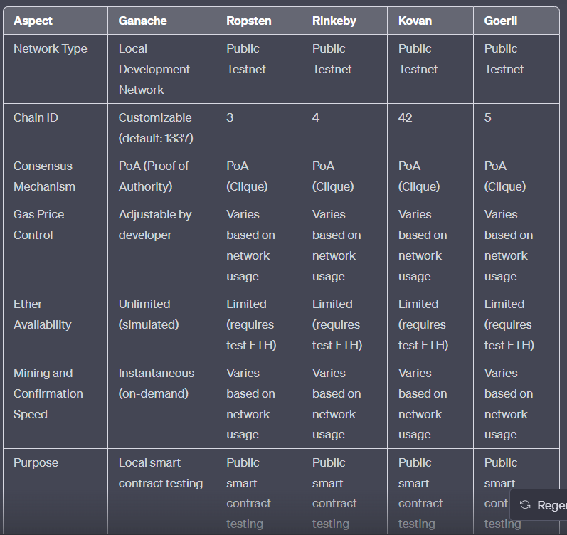

Whether Ganache is better than other test networks like Ropsten, Rinkeby, Kovan, or Goerli depends on your specific use case and development needs. Each of these networks serves a different purpose, and the choice should be based on your project requirements. Here are some considerations to help you decide:

**Ganache:**

1. **Advantages:**

- Instant transactions: Transactions on Ganache confirm instantly, making it very convenient for rapid development and debugging.

- No need for test ETH: Ganache simulates Ether without needing to obtain test ETH from faucets, simplifying the development process.

- Customizable: You can customize Ganache to suit your specific development needs, including adjusting gas prices and the number of accounts.

2. **Use Cases:**

- Best for local development and testing.

- Ideal for quick, iterative development of smart contracts.

**Public Testnets (Ropsten, Rinkeby, Kovan, Goerli):**

1. **Advantages:**

- Real-world simulation: Public testnets mimic the behavior of the main Ethereum network more closely, providing a more realistic testing environment.

- Easier collaboration: Public testnets allow multiple developers to collaborate on the same network, similar to the mainnet.

2. **Use Cases:**

- Suitable for testing smart contracts in an environment similar to the Ethereum mainnet.

- Useful for testing interactions with external services and other dApps.

Ultimately, the choice between Ganache and public testnets depends on the stage of your development and the specific goals of your project. Developers often use both, starting with Ganache for rapid local development and later testing on a public testnet to ensure their smart contracts behave correctly in a real-world context. Ganache is a valuable tool for initial development and debugging, but public testnets are crucial for more comprehensive testing and integration with the broader Ethereum ecosystem.

In summary, there's no one-size-fits-all answer, and the best choice depends on your development needs and goals.

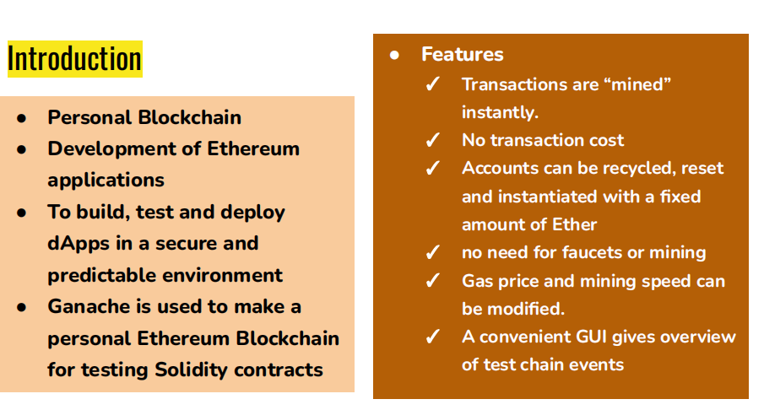

Ghost protocol used , pow ethash, heaviest chain